3D Visualization of medical images

Maryam Ghobadi1, Arash Azimzadeh Irani2*, Reza Pourgholi3

1 Department Mathematics and computer science, Damghan University, Damghan , Iran

2 Department Mathematics and computer science, Damghan University, Damghan, Iran

3 Department Mathematics and computer science, Damghan University, Damghan, Iran

[a.azimzadeh@du.ac.ir](mailto:a.azimzadeh@du.ac.ir)

**Abstract— In medical field, visualizing the internal structure of body is very important for proper medical diagnosis. To aid doctors in visualizing the internal body parts, scanning methods like MRI (Magnetic Resonance Imaging), X-ray and CT (Computed Tomography) scan are used. Output of such methods are generally one or more grayscale 2D images. It is difficult to visualize the internal structure with the help of these 2D images. In reality, all the tissues and organs of human body are 3D, so it is almost impossible to determine the accurate spatial location and shape/size of ROI (region of interest) only with 2D slices produced by MRI. To solve this problem, we propose a 3D volume rendering and visualization technique for 2D dataset. This paper proposes a ray casting algorithm for accurate allocation and localization of human abdomen organs. Magnetic resonance images (Abdomen MRI) of patients are used.**

***Keywords—Medical images, 3-D visualization, Direct Volume Rendering, Ray casting, Abdomen MRI***

# Introduction

3-D Visualization of volumetric medical data is an important aspect of image processing and it has shown as a promising research area due to its significance in the medical domain. The main phases in the direct volume rendering are the classification and the rendering stages.

Shihao et al. [1] propose a direct volume rendering with 3D texture using hardware-assisted texture mapping. As the outstanding challenges in medical domain is how to render a 3D image fast, the implementation uses trilinear interpolation to accelerate rendering speed. Some samples of a human MRI head data set, beetle CT scan and hand CT scan data set were exploited.

Visualization Tool Kit from Kitware Inc. has been a great research development tool for research. Ling et al. [2] employ the use of VTK for context-preserving volume rendering. The idea was to contribute to the improvement of Maximum Intensity Projection (MIP) technique. Local Maximum Intensity Projection (LMIP) is an extended version of MIP introduced to overcome the shortcoming of MIP which is its inability to adequately depict the spatial relationships of overlapping tissues. The work presents a better and improved Local Maximum Intensity Projection that computes threshold and shading for LMIP.

With the faster and more stable Graphics Processing Units (GPUs) from Intel, Chen & Hao implemented a GPU-based volume ray casting for re-sampling and representation of 3-D texture. Fragment shaders were performed with the ray casting algorithm. human male CT, human head MRI and pet chest data scan were used for the experiment. The research proved an interactive speed with the algorithm for large dataset.

Ray casting technique has been noted to produce high-quality images in direct volume rendering. Kim & aja [3] implemented cell processor architecture for broadband engine with regular datasets for direct volume rendering. Similarly, Cox et al. [4] propose parallel cell architecture broadband engine processor for speeding up the ray casting of irregular datasets. The work still requires optimization of the approach.

Direct Volume Rendering involves sampling of data. The sampling stage is carried out typically with the use trilinear interpolation, in order to ensure efficient and quality images. In some cases, quadratic or cubic filters are used for higher image quality but they are expensive to evaluate even with GPU acceleration. In addition, Csébfalvi & Domonkos [5] propose a frequency-domain sampling on an optimal Body-Centered Cubic (BCC) lattice, which was demonstrated to have similar quality as cubic filters.

# MATERIALS AND METHODS

## Ray casting

Ray casting is an image-order volume rendering technique firstly proposed by Levoy in 1988 (Gong & Wang 2010) [6]. In ray casting, rays are cast into the dataset. Each ray originates from the viewing point, and penetrates a pixel in the image screen, and passes through the dataset. At evenly spaced intervals along the ray, sample values are computed using interpolation. The sample values are mapped to display properties such as opacity and color. Final pixel values are found by compositing the color and opacity values along the ray. The composition models the physical reflection and absorption of light. Composite ray casting is a flexible approach for visualizing several semitransparent surfaces contained in the data and produces high quality images.

## Algorithm Overview

For each pixel:

* Calculate ray from viewer point through pixel
* Find intersection points with scene objects (e.g., a sphere)
* Calculate the color at the intersection point near to viewer (e.g., Phong illumination model)

Equation of the ray passing through a pixel:

|  |  |
| --- | --- |
| (1) | $$x(t) = o + tv$$ |

Where o is the camera (eye) position, v is the vector that stands for the direction of the ray starting

at o and passing through pixel (i,j)

|  |  |
| --- | --- |
| (2) | $$v=\frac{x-o}{ǁx-0ǁ}$$ |

Where x is the float-point location of the window corresponding to the pixel (i,j) of a discrete view screen (in the view plane) of resolution (W,H):

Side view of camera at o:

* Position of the i-th pixel x[i]
* Let us first agree that:

|  |  |
| --- | --- |
| (3) | **P0 = ō+d l – dtan(θ)u** |
| (4) | **P1 = ō+d l *+* dtan(θ)u** |
| (5) | **h = 2d tan(θ)** |

* Also:

|  |  |
| --- | --- |
| (6) | $$\text{x[}\text{i}\text{]}=\frac{i+0.5}{H}({\text{p}}_{\text{1}}-{\text{p}}_{\text{0}})$$ |

So

|  |  |
| --- | --- |
| (7) | $$\text{x[}\text{i}\text{]}=\frac{i+0.5}{H}hu$$ |

Where o origin of camera (pinhole), l look vector, u up vector, H discrete height of screen (in pixels), h height of screen, d distance to screen, θ field of view (FOV).

Top view of camera at o:

* Position of the j-th pixel x[j]
* Analogously, we have:

|  |  |
| --- | --- |
| (8) | $$\text{x[j]}=\frac{i+0.5}{W}wv$$ |

Where o origin of camera (pinhole), l look vector, u up/side vector, W discrete width of screen (in pixels), w width of screen, d distance to screen, θ field of view (FOV).

In conclusion The equation of the ray through each pixel (i,j) is given by:

|  |  |
| --- | --- |
| (9) | $$x[i,j]=o+\frac{i+0.5}{H}hu+\frac{j+0.5}{W}wv$$ |

## Proposed system

A flowchart may be of great importance towards better understanding of the Ray casting Method presented in this section. Figure 1 is therefore provided prior to any further elaboration.

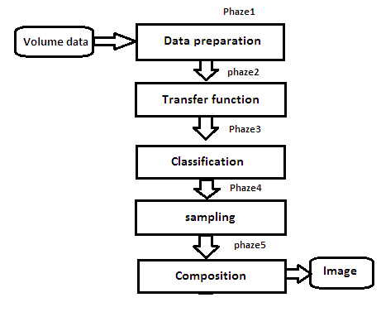

1. Flowchart of Ray casting method

Phaze 1-Data preparation: The first step is data preparation, which could be any processing from checking that voxels are aligned correctly to interpolation of grids to increase the number of voxels on one axis.

Phaze 2 and 3-Transfer function and classification: Ray casting requires classification and shading stages. Transfer functions are used to perform classification and shading in DVR by assigning color and opacity to each sample in the data based on a measured property. The ability to differentiate between different tissues is of great importance to medical images. Color Transfer Function and Opacity Transfer Function are for color and opacity assignment respectively. Classification for volume rendering is the assignment of color and opacity through the volume. Color and opacity are assigned to as scalar (s) within the volume through a user specified mapping called a transfer function. The shading and classification transfer functions were set using *vtkColorTransferFunction* and *vtkPiecewiseFunction* respectively.

Phaze 4-Sampling: In the third step, the volume is set up for the ray casting stage. Rays are cast into the volume from each pixel on screen. Each ray is sampled at equidistant intervals, every sample is determined using tri-linear interpolation.

Estimating the sample value requires evaluation of the tri linear interpolation equation:

|  |  |
| --- | --- |
| (10) | **(u,v,x)= C000(1-u)(1-v)(1-w)**  **C100u(1-v) (1-w) + C010 (1-u)v(1-w)**  **+ C110 u v(1-w) + C001 (1-u) (1-v)w**  **+ C101 u(1-v)w + C011 (1-u)v w + C111 uvw** |

Where

|  |  |
| --- | --- |
| (11) | $$u=\frac{x-x_{0}}{x_{1-}x_{0}}$$ |
| (12) | $$v=\frac{y-y_{0}}{y_{1-}y_{0}}$$ |
| (13) | $$w=\frac{z-z_{0}}{z_{1-}z_{0}}$$ |

u, v, and w are fractional off sets of the sample position in the x, y, and z directions, respectively. These variables are between 0 and 1.

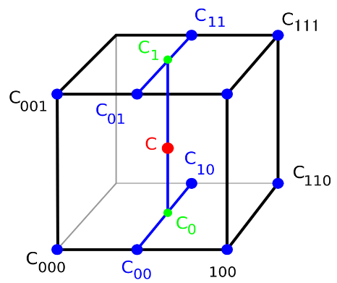

1. Tri-linear interpolation

Phaze5-Composition: After a sample has been classified and shaded, the last step before moving to the next sample is to blend it with the previous samples using compositing. Just as rearranging plates of different colored glass will change the color of objects seen through the plates, the order in which the data is composited will change the results of the volume rendering. The compositing algorithm for back-to-front slicing is computed as a function of RGB color C and opacity α [7]:

|  |  |
| --- | --- |
| (14) | $$C out = C in (1-α new) + C new α new$$ |

And for front-to-back order:

|  |  |
| --- | --- |
| (15) | $$C out = C new α new (1 – α in) + C in α in$$ |
| (16) | $$α out = ( 1 – α in) α new + α in$$ |

C new and α new are the color and opacity values of the newly calculated voxel contributing to a particular pixel, while, C out, in , and α out, in are the accumulated color and opacity values at the pixel from which the ray is emanating after and before the ray passes through the new voxel [8].

In this paper, we applied front-to-back compositing because it facilitates acceleration techniques such as early-ray termination, which prevents compositing after a pre-defined opacity has been reached (e.g., 80% opaque). This method avoided unnecessary computation by skipping regions of the volume that are obscured in the current view. This step was done using the VTK class vtk VolumeRayCastCompositeFunction.

# RESULTS

Based on the algorithm and technique introduced above, we have experimented MRI volume (MRI: 512x512x119 voxels) with our system and converting it to a three-dimensional model. And the results are presented in the form of the following images in this paper.

## Demonstration

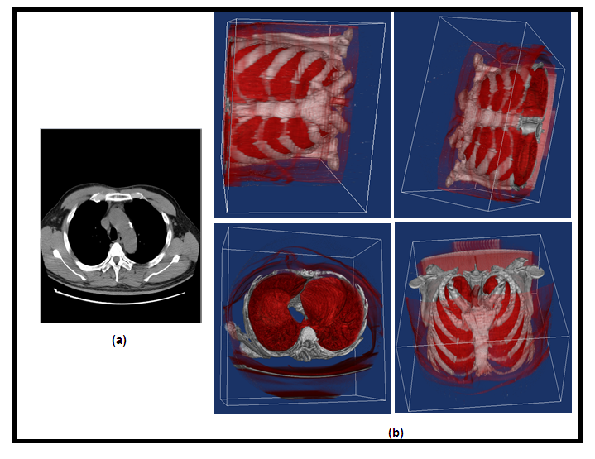

1. (a) MRI data of chest (b) 3D volume data of chest

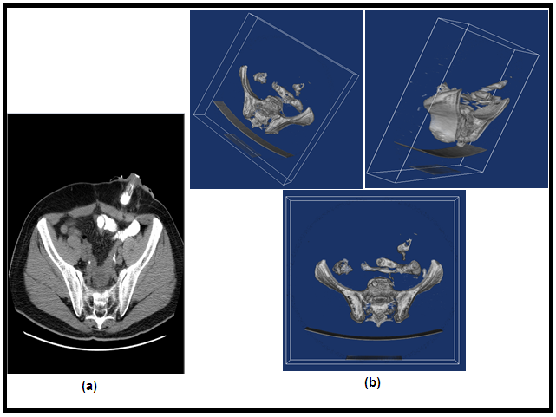

1. (a) MRI data of pelvis and hip (b) 3-D volume data of pelvis and hip

## Analysis

This section elaborates on the figures presented. As may be noticed, figures 3 and 4 present the ray casting methodology of this paper. According to the above figures, it is easier to diagnose the disease in 3D images and stained by ray casting method. In Figure 3, the distinction between lung tissue and rib bones is clearly marked by discoloration and it is making easy to diagnose pneumothorax, emphysema, and rib fracture.

# CONCLUSION

With volume visualization, we can make the boundaries of the object transparent and hence the inner part would become visible. Making the 2-D image structure of Abdomen MRI visible by converting it to 3-D model will facilitate in medical analysis. Hence, Ray casting for direct volume rendering of abdomen MRI will be a meaningful contribution to the application of MRI data in human Abdomen diagnosis and treatment.

##### **References**

1. C. Shihao, H. Guiqing,and H. Chongyang, “Rapid texture-based volume rendering, ” Conf. Envir. Sci. Info. App. Tech., 2009.
2. F. Ling, L. yang, Z.K Wang, “Improvement on direct volume rendering, ” Image. Signal.Proc., October 2009.
3. J. Kim, J. Jaja, “Streaming model based volume ray casting implementation for cell broadband engine, ” Sci. Program., vol. 17, pp. 173-184, 2009 .
4. G. Cox, A. Maximo, C. Bentes, R. Farias, “Irregular grid ray casting implementation on the cell broadband engine, ” proc. IEEE. Comput. Archite. High. Perform. Comput, pp. 93-100, November2009.
5. B. Csebfalvi, B. Domonkos, “Frequency-Domain upsampling on a Body-Centered Cubic Lattice for E_cient and High-Quality Volume Rendering ” Vision. Model. Vis., pp.225-232 ,2009.
6. F. Gong, H. Wang, “An Accelerative ray casting algorithm based on crossing-area tech- nique, ” Conf. Mach. Vision. Human. mach. Inter., April 2010.
7. J. Kruger, R. Westermann, “Acceleration Techniques for GPU-based Volume Rendering, ” IEEE. Vis., pp. 19-24, December 2003.
8. C. Barrilot, “Surface and Volume Rendering Techniques to Display 3D Data, ” Proc. IEEE. Eng. Med. Biol. Soc., vol. 12, pp. 111-119 , March1993.