**Survival analysis of Ovarian Cancer patients in Yazd of Iran from 1999-2018**

**Background**: Ovarian Cancer (OC) as a common gynecologic cancer according to mortality rate has the seventh rank among women in the world.This study aimed to identify risk factors associated with OC survival in Yazd, Iran.

**Methods**: In this observational retrospective cohort study, the medical records of 150 patients who were definitively diagnosed with OC at Shah Vali Hospital, Yazd, Iran from 1999 to 2018 were investigated. The Kaplan–Meier estimator and the Cox proportional hazard model with hazard ratio and the log-rank test was used to data analysis. All statistical analyses were done in R 4.0.5, package survival. 5% was considered as significant level.

**Results**: 60.77% (91 people) of patients were under 60 years old. 32.7% (49 people) were in stage III of disease. 62% (93 people) did not have ascites, 67.3% (101 people) had disease-free survival more than 65 months. 45 (30%) of 150 patients were dead. Median survival time was 96 months (95% CI∶57.20 to 134.79), one, three, five, and ten years' survival rates were 83,73,55and 33 months; respectively. log-rank test results showed there was a significant difference between age, stage,ascites, disease-free survival, Treatment method, CA125 after and before treatment (p<0.05). Cox proportional hazard model result showed ascites (HRadj =3.89, 95%CI:1.35to11.15,P =0.01) and DFS (HRadj =23.52, 95 % CI:4.21to128.33, p = <0.001) as significant covariates.

**Conclusion:** The results of our study showed that   disease-free survival and ascites are the main risk factors for OC and paying attention to them will be effective in increasing patient survival.

**Keywords:** Ovarian Cancer, Survival, Cox proportional hazard, Iran

**Introduction**

Cancer is one of the leading causes of death among non-communicable diseases (1). Ovarian Cancer (OC), like other cancers, is on the rise and is of great importance to women (2). According to previous studies, OC is the most common cause of death among women with malignancies (3). Due to asymptomatic development, the disease is often diagnosed in advanced and incurable stages. it is now the seventh most common cancer in women worldwide and the eighth-most common cause of death and morbidity in women under 65 years of age (4). The high mortality rate is the result of late diagnosis, which is one of the reasons for not performing screening tests that can be used in low-risk populations (5). Ovarian malignancies cause accounting for about 33% of all invasive female genital malignancies (6).

OC is the most common cause of death from genital cancer, and usually, 90% of women with early-stage disease have symptoms such as premature satiety, unusual pelvic or abdominal pain, urinary problems, and postmenstrual bleeding (6) Wu et al. 2019 in their survival study on 59,763 patients with OC showed the highest and lowest survival rate was related to the age group over 79 years under 20 y

ears, respectively. they found that increasing age is associated with improved patient prognosis (7). Najla et al. 2015 declared that obesity is an important factor in reducing the survival rate in OC patients (8). Among studies related to OC in Iran, Sharifian et al. 2014 in their study on the incidence and mortality of OC in Iran found that OC is one of the leading causes of death among Iranian women, during the time it had increasing trend also older women had a lower response to treatments (9). Jaleh et al. 2012 on their survival study in Fars province of Iran, with study 201 women found that the variables of first menstrual age, metastasis to other near and far places, and history of abortion were associated with survival time of patients (10). OC is still the leading cause of cancer death in women in developed countries. Despite significant progress in the management of OC, the overall 5-year survival rate at all stages of the disease is estimated at 30%, and in Iran 61%(6, 11). In the United States, in 2018, approximately 22,240 new cases of OC were diagnosed, of which 14,070 deaths occur from OC, so the American Cancer Society provides an overview of the incidence of OC and its population-based mortality across the country. in this country, the overall rate of OC from 1985 (6.16 per 100,000) to 2014 (11.8 per 100,000) was 29% and the mortality rate was between 1976 (10.0 per 100,000). And 2015 (7/6 per 100,000) decreased by 33% (12).

Due to the lack of a study on OC in recent years in Iran, the present study was conducted to evaluate the survival rate of OC patients in Yazd province, the central part of Iran, from 1999 to 2018 and identify related factors.

**Materials and methods**

In this observational retrospective cohort study, medical records of 150 OC patients   who referred to Shah Vali Medical Center in Yazd province, (Central part of Iran) between 1999 and 2018 were investigated. The researcher used the medical records and also telephone contact to data gathering.  Patients who did not consent to participate in this study or whose medical records were incomplete were excluded from the study. The variables of this study include demographic variables such as age at diagnosis (≤60, >60 ), body mass index(BMI,≤25,25 to 30,>30), married(yes,no)and clinical variables such as treatment method (Surgery then chemotherapy, Chemotherapy then surgery, Surgery only, Chemotherapy only), disease stages (I,II,III,IV), metastasis to other parts of the body ( yes no), ascites(yes,no), recurrence(yes,no) disease-free survival (DFS, ≤65, >65)  Oral contraceptive pills(OCP, yes,no), family history of  OC(yes,no), other cancers(yes,no)andCancerantigen125(ca-125,≤11585,>11585u/ml)beforeandca-125(,≤3000,>3000 u/ml) after treatment.

Patients' survival time was calculated as the time of diagnosis of OC to the time of death (or the last follow-up).

The Kaplan–Meier estimator was used to estimate survival function in different survival times. To compare and evaluate the difference in patient survival in the subgroups of the study variables, the log-rank test was used. In order to identify the factors affecting patient survival, univariate/ multivariable Cox proportional hazard (CPH) model was used and Hazard ratios (HRadj) with 95% CIs were estimated. assumption of (CPH) such as establishing proportional Hazard assumption (PH assumption)) in each of the variables were checked by Schoenfeld residuals.  After performing the univariate model, according to Hosmer and Lemeshow variable selection process, varibles were entered into the multivariable (CPH). All statistical analyses were done in R4.0.5, package survival. Pvalue less than 0.05 was consider significant.Our study was approved by the Ethics Committee of the Yazd University of Medical Sciences, Yazd, Iran (IR.SSU.SPH.REC.1399.095).

**Results**

out of a total of 150 OC patients, 60.77% (91 people) had age under 60 years, 92.7 % (139 people) had married status, 32.7% (49 people) were in stage number one(I) of disease, 48% (72 people) underwent dual treatment, first surgery and then chemotherapy,38% (57 people) had ascites, 78%(117 people) had used OCP.  82.7 % (124 people) had no metastasis and 32.7 % (47 people) had recurrence after treatment. At the end of this study, overall 45 deaths (30%) of 150 patients were died (see table 1).

Using the Kaplan-Meier estimator as a nonparametric method, different survival times were calculated, so that the overall median survival time was 96 months (95%CI ∶57.20to134.79), the overall mean survival rate 84.05 was (95%CI 73.84to94.62), and of1,3,5 and 10-year survival rate were obtained 83,73,55and33 percent, respectively.

Results of Log-rank test showed a significant difference in survival rate in    age (p = 0.005), disease stage (p = 0.001), metastasis (p = 0.018) and Surgery then chemotherapy (p = 0.031), the amount of ca125 after treatment (p = 0.01) receiving DFS (p <0.001). pairwise multiple comparisons result in disease stage and treatment method, which had more than two levels, showed that stage one had a significant different survival rate with stage three and four (p<0.001); stage two had a significant different survival rate with stage three and four (p<0.001).  Also, differences in the survival rate of treatment methods were significant so that method Surgery then chemotherapy and Chemotherapy then surgery (p<0.04), method Surgery then chemotherapy and Surgery only (p<0.008) had significant difference. However, no significant differences were observed in other subgroups (p>0.05) (table 1).

**(Table 1)**

The Kaplan-Meier survival plot showed Overall Survival Estimates among OC Patients with a 95% Confidence Interval. age at diagnosis OC patients indicated lower survival in the youngest age group. (see Figure 1).

**(Figure 1)**

patients were in stage number one(I) of the disease had a longer survival estimate than Other stages of the disease (II, III.IV) throughout almost the entire study period. The survival curve by treatment method indicated lower survival in the Surgery only group. patients who have undergone surgery only had the highest survival estimates. (see Figure 2).

**(Figure 2)**

OC patients with ascites and no ascites had the lowest and highest survival probabilities, respectively. Also, Patients with DFS more than 65 months had a longer survival estimate than Patients with DFS less than 65 months. (see Figure 3).

**(Figure 3)**

 The Schoenfeld residuals test showed no serious violation from the proportional Hazard assumption (p>0.05).

Results of the univariate CPH model showed that the variables of patient age at diagnosis, stage of the disease, metastasis to other parts of the body, ascites, duration of relapse and treatment, ca125 before and after the disease, Recurrence of the disease, and ascites are related to patients' survival (p <0.05).

rsults of multivariable CPHwith adjusting potential confounders showed ascites and DFS with HRadj =3.89 (95 % CI,1.35-11.15, p-value=0.01), HRadj =23.52 (95 % CI,4.21-128.33, p-value= <0.001); respectively as significant variables (Table2).

**(Table 2 )**

According to the results in Table 2, the risk of death for patients with a recurrence of fewer than 65 months was 23.52 times higher than for patients with a recurrence of more than 65 months. Also, the risk of death for people with ascites was 3.89 times higher for people without ascites**.**

**Discussion**

OC has the highest mortality rate of all gynecological cancers worldwide and is frequently (*>*75%) diagnosed at an advanced stage (13). At the end of our study, overall 45 deaths (30%) of 150 patients. Factors such as age at diagnosis BMI, married, treatment method, disease stages, metastasis, recurrence, DFS, OCP, family history of OC, other cancers, and ca-125 before and after treatment were risk factors for OC. In this study, we found that Ascites and DFS is the most important independent predictor of survival in patients with ovarian cancer in Yazd region of Iran. Which is compatible with the multivariable CPH model with Eisenkop and et al (14). in addition, DFS in our study was more than 65 months, this may be due to the long study time of our study (19 years). Over time, DFS estimates for patients with ovarian cancer improve dramatically, especially in those with poorer initial prognoses (15).

Ascites(uh-SIGH-tees) refers to excess fluid in the abdomen. This fluid collects in the space within the wall so the abdomen, between the abdominal organs. It is common in patients with liver disease and cirrhosis, though patients with cancer can also develop ascites (16). Malignant ascites is frequently found in OC, but also in various other solid tumor entities (17-19). According to the National Cancer Institute, malignant ascites is defined by the accumulation of fluid containing cancer cells in the abdomen (20). Malignant ascites generally resolves when the underlying disease is successfully treated (21).

 the adjusted hazard ratio for patients who had DFS lower than 65 months was 23.52 times higher than for patients with DFS more than 65 months. Also, the adjusted hazard ratio for patients with ascites was 3.59 times higher than for patients without ascites.

 In our study, most patients were in the stage(IV) of the disease, which was consistent with the studies (22, 23) the adjusted Hazard ratio for patients with the stage(IV) was 15.91 higher than for patients' stage (I) which was not consistent with the studies (22, 24, 25).

 The median survival time was 96 months (95% CI,57.204- 134.79), the overall mean survival rate 84.05 was (95% CI,73.84- 94.62), and of 1,3,5,10-year survival rate were obtained 83,73,55,33 months, respectively. Which did not in line with the study conducted Quan-Qing Zheng et al. on survival of ovarian cancer (26), they found that one, three, and five years' survival rate were 87.7%, 50.8%, and 31.1%, respectively.   this issue may be due to different geographical areas, medical facilities, disease-related features such as the stage of diagnosis, marital status.

 Most of the patients in our study were less than 60 years old, which was consistent with the studies (23, 26-29). Results of our study in comparing survival in the subgroups of study variables showed age at diagnosis, disease stage, ascites, and treatment methods were significant (p <0.05). The median survival function was 96 months for people under 60 years of age and 98 months for people over 60 years of age, indicating lower survival of young women than middle-aged women, which was consistent with a study conducted by Wang et al. in 2019 (7). most patients in our study were in the third stage of the disease, the median survival time for them was 36 months, this finding was consistent with Lund et al. study, in which most patients were in the same stage, but the median survival time was 16 months (30). Given that this study was conducted in 1991 and our study in 2018, this could be due to the development of treatment methods. Also, the median survival time was 120 months for those without metastasis and 96 months for those with metastases, which was a significant difference in survival time.  Also, the median survival time was 120 months for those with a family history of OC and 96 months for those without a family history of cancer, which was a significant difference in survival. This may be due to the fact that people with a family history go to the doctor sooner to get acquainted with the disease and fear of recurrence and advance the treatment process.

 our results also showed the median survival time for patients with ascites was 48 months, which was inconsistent with a similar study by Wang et al that they declared survival time for the same group was 16 months (30). Most of the patients in our study did not have metastases, which may be due to a large number of patients in the first stage. results of the univariate CPH model showed, the variables such as age at diagnosis, stage of the disease, ascites, metastasis, ca125 before and after treatment, DFS, Chemotherapy then surgery were significant, this founding was in line with the Eisenkop et al study on OC (11).

In this study in terms, os strength should be noted to the long follow-up time of patients as well as the most complete information of patients' medical records. there were limitations to the small sample size and our research was done only on patients of a hospital in Yazd.

**Conclusion**

OC as a common gynecologic cancer according to mortality rate has the seventh rank among women in the world. The results of the multivariable CPH model our study showed that the variables DFS, Ascites are the main risk factors for OC, and paying attention to them will be effective in increasing patient survival. Contrary to expectations, the age variables of patients at the time of diagnosis and stage of the disease, which were identified as influential variables in most studies, were not significant in this study.

**Acknowledgments**

The authors thank the staff of the Shah Vali Medical Center in Yazd province for their sincere cooperation in this study.

**Conflict of interest**

The authors have no conflicts of interest to declare for this study.

**References:**

1. Momenimovahed Z, Tiznobaik A, Taheri S, Salehiniya H. Ovarian cancer in the world: epidemiology and risk factors. International journal of women's health. 2019;11:287.

2. La Vecchia C. Ovarian cancer: epidemiology and risk factors. European journal of cancer prevention. 2017;26(1):55-62.

3. Kujawa KA, Lisowska KM. Ovarian cancer--from biology to clinic. Postepy higieny i medycyny doswiadczalnej (Online). 2015;69:1275-90.

4. Chuffa LGA, Lupi Júnior LA, Seiva FbR, Martinez M, Domeniconi RF, Pinheiro PFF, et al. Quantitative proteomic profiling reveals that diverse metabolic pathways are influenced by melatonin in an in vivo model of ovarian carcinoma. Journal of proteome research. 2016;15(10):3872-82.

5. Dinca AL, Birla RD, Dinca VG, Marica C, Panaitescu E, Constantinoiu S. Prognostic factors in advanced ovarian cancer–a clinical trial. Chirurgia (Bucur). 2020;115(1):50-62.

6. Högberg T, Bergfeldt K, Borgfeldt C, Holmberg E, Åvall Lundqvist E. Hopp om förbättring av överlevnad i ovarialcancer. Läkartidningen. 2015;112.

7. Wu S-G, Wang J, Sun J-Y, He Z-Y, Zhang W-W, Zhou J. Real-world impact of survival by period of diagnosis in epithelial ovarian cancer between 1990 and 2014. Frontiers in oncology. 2019;9:639.

8. Nagle C, Dixon S, Jensen A, Kjaer S, Modugno F, DeFazio A, et al. Obesity and survival among women with ovarian cancer: results from the Ovarian Cancer Association Consortium. British journal of cancer. 2015;113(5):817-26.

9. Sharifian A, Pourhoseingholi MA, Norouzinia M, Vahedi M. Ovarian cancer in Iranian women, a trend analysis of mortality and incidence. Asian Pacific Journal of Cancer Prevention. 2015;15(24):10787-90.

10. Najafi Z, Rivaz M, Shokrollahi P, Shamsnia M. Survival rate of women with ovarian cancer in Fars Province, Iran. Hormozgan Medical Journal. 2013;16(6):459-65.

11. Sienko J, Gaj P, Czajkowski K, Nowis D. Peroxiredoxin-5 is a negative survival predictor in ovarian cancer. Ginekologia polska. 2019;90(1):1-6.

12. Torre LA, Trabert B, DeSantis CE, Miller KD, Samimi G, Runowicz CD, et al. Ovarian cancer statistics, 2018. CA: a cancer journal for clinicians. 2018;68(4):284-96.

13. Ahmed N, Stenvers K. Getting to know ovarian cancer ascites: opportunities for targeted therapy-based translational research. Frontiers in oncology. 2013;3:256.

14. Eisenkop SM, Friedman RL, Wang H-J. Complete cytoreductive surgery is feasible and maximizes survival in patients with advanced epithelial ovarian cancer: a prospective study. Gynecologic oncology. 1998;69(2):103-8.

15. Kurta ML, Edwards RP, Moysich KB, McDonough K, Bertolet M, Weissfeld JL, et al. Prognosis and conditional disease-free survival among patients with ovarian cancer. Journal of clinical oncology. 2014;32(36):4102.

16. Gupta A, Sedhom R, Beg MS. Ascites, or Fluid in the Belly, in Patients With Cancer. JAMA oncology. 2020;6(2):308-.

17. Smolle E, Taucher V, Haybaeck J. Malignant ascites in ovarian cancer and the role of targeted therapeutics. Anticancer research. 2014;34(4):1553-61.

18. Loggie BW, Perini M, Fleming RA, Russell GB, Geisinger K. Treatment and prevention of malignant ascites associated with disseminated intraperitoneal malignancies by aggressive combined-modality therapy. The American surgeon. 1997;63(2):137-43.

19. Sebastian M. Review of catumaxomab in the treatment of malignant ascites. Cancer management and research. 2010;2:283.

20. Barni S, Cabiddu M, Ghilardi M, Petrelli F. A novel perspective for an orphan problem: old and new drugs for the medical management of malignant ascites. Critical reviews in oncology/hematology. 2011;79(2):144-53.

21. Cohen M, Petignat P. The bright side of ascites in ovarian cancer. Taylor & Francis; 2014.

22. Oldak S, Ioannou S, Kamath P, Huang M, George S, Slomovitz B, et al. Polypharmacy in patients with ovarian Cancer. The oncologist. 2019;24(9):1201.

23. Wang L, Li X. Identification of an energy metabolism‑related gene signature in ovarian cancer prognosis. Oncology reports. 2020;43(6):1755-70.

24. Hsieh S-F, Lau H-Y, Wu H-H, Hsu H-C, Twu N-F, Cheng W-F. Prognostic factors of early stage epithelial ovarian carcinoma. International journal of environmental research and public health. 2019;16(4):637.

25. Chen Y, Bi F, An Y, Yang Q. Identification of pathological grade and prognosis‐associated lncRNA for ovarian cancer. Journal of cellular biochemistry. 2019;120(9):14444-54.

26. Zheng Q-Q, Wang P, Hui R, Yao A-M. Prognostic analysis of ovarian cancer patients using the Cox regression model. Ai zheng= Aizheng= Chinese journal of cancer. 2009;28(2):170-2.

27. Zhang X-y, Zhou L-l, Jiao Y, Li Y-q, Guan Y-n, Zhao Y-c, et al. Adenylate kinase 7 is a prognostic indicator of overall survival in ovarian cancer. Medicine. 2021;100(1).

28. Urpilainen E, Marttila M, Hautakoski A, Arffman M, Sund R, Ilanne-Parikka P, et al. Prognosis of ovarian cancer in women with type 2 diabetes using metformin and other forms of antidiabetic medication or statins: a retrospective cohort study. BMC cancer. 2018;18(1):1-9.

29. Dixon-Suen SC, Webb PM, Wilson LF, Tuesley K, Stewart LM, Jordan SJ. The Association between hysterectomy and ovarian cancer risk: a population-based record-linkage study. JNCI: Journal of the National Cancer Institute. 2019;111(10):1097-103.

30. Lund B, Williamson P. Prognostic factors for overall survival in patients with advanced ovarian carcinoma. Annals of Oncology. 1991;2(4):281-7.

|  |  |  |  |  |  |
| --- | --- | --- | --- | --- | --- |
|  | Log-rank test | | N(%) | Levels | Factors |
| Pair-wise comparison | p | Median survival times( months) (95% C.I) |
| --- | 0.005 | 96 | 91(60.7) | 60≥ | Age at diagnosis (yr) |
| 98(35.341-100.659) | 59(39.3) | 60< |
| --- | 0.447 | 96(63.89-128.10) | 139(92.7) | yes | Married |
| --- | 11(7.3) | No |
| (1-2)&(1-3)*&(1-*4) | 0.001 | --- | 47(31.3) | I | Stage |
| (2-3)*(2-4)* | --- | 34(22.7) | II |
| (3-4) | 48(18.58-77.41) | 49(32.7) | III |
|  | 36(13.39-58.60) | 20(13.3) | IV |
| --- | 0.001 | 42(16.47-67.52) | 57(38) | yes | Ascites |
| --- | 93(62) | No |
| --- | 0.154 | --- | 33(22) | yes | Ocp |
| 69(43.36-94.63) | 117(78) | No |
| --- | 0.018 | 69(21.62-116.38) | 26(17.3) | yes | Metastatic |
| 120(48.26-25.39) | 124(82.7) | No |
| --- | 0.178 | 69(66.132-71.86) | 45(30) | yes | Recuarence |
| --- | 105(70) | No |
| (1-2)*&(1-3)*&(1-4) | 0.031 | 120 | 72(48) | Surgery then chemotherapy | Treatment method |
| (2-3)&(2-4) | 68(25.97-110.02) | 25(16.7) | Chemotherapy then surgery |
| (3-4) | 96(22.61-169.38) | 40(26.7) | Surgery only |
| --- | --- | 13(8.7) | Chemotherapy only |
| --- | 0.471 | 69(42.37-95.62) | 137(91.3) | yes | Othercancer |
| 120(35.47-189.52) | 2(1.3) | No |
| --- | 0.43 | 96(59.75-132.24) | 133(88.7) | yes | , family history of OC |
| 120(37.46-202.54) | 17(11.3) | No |
| --- | 0.17 | 120(27.76-212.24) | 80(53.3) | ≤25 | BMI( kg/m2) |
| 96(66.52-125.47) | 48(32) | 25to30 |
|  | 96(66.52-125.47) | 22(14.7) | 30< |
| --- | 0.02 | 96(57.26-134-73) | 136(90.7 | 11585≥ | Ca-125 (U/ML) before treatment |
| 26(16.16-35.83) | 14 (9.3) | 11585< |
| --- | 0.01 | 96(57.26-134-73) | 137(91.3) | 3000≥ | Ca-125 (U/ML) after treatment |
| 22 | 13 (8.6) | 3000< |
| --- | 0.001> | 60(46.82-76.18) | 133(88.7) | ≤65 | DFS(months) |
| --- | 17(11.3) | >65 |

**Table 1**. Descriptive statistics of Ovarian cancer risk factors and results of log-rank test

OC, Ovarian cancer, 95% CI, 95% confidence interval ,BMI, body mass index,ca-1251, Cancer antigen 125 before treatment ,Ca-1252, , Cancer antigen 125 after treatment,Ocp, Oral contraceptive pills, DFS, Disease Free Survival, p,p-value, *p < 0.05 log-rank test

**Table 2**. Results of univariate and multivariable Cox proportional hazard model

|  |  |  |  |  |  |
| --- | --- | --- | --- | --- | --- |
| Multivariable analysis | | Univariate analysis | |  | |
| p | HRadj (95%C.I) | p | HR(95%C.I) | Levels | Factors |
| 0.92 | Refrence | 0.007 | Refrence | 60> | Age at diagnosis (yr) |
| 0.96(0.42-2.15) | 2.33(1.26-4.309) | 60< |
| --- | -- | 0.45 | 2.12(0.28-15.56) | yes | Married |
| --- | Refrence | No |
| -- | Refrence | --- | Refrence | I | Stage |
| 0.507 | 1.82(0.30-10.37 | 0.33 | 2.24(0.43-11.62) | II |
| 0.08 | 4.55(0.83-24.76) | 0.001 | 13.316(3.15-56.23) | III |
| 0.41 | 2.45(0.28-21.35) | 0.001 | 15.91(3.58-70.64) | IV |
| 0.01 | 3.89(1.35-11.15) | 0.001 | 6.26(3.22-12.16) | Yes | Ascitec |
| Refrence | Refrence | No |
| 0.07 | Refrence | 0.16 | Refrence | Yes | OCP |
| 2.93(0.89-9.62) | 1.84(0.78-4.36) | No |
| 0.94 | 1.05(0.22-4.84) | 0.02 | 2.12(1.11-3.96) | Yes | Metastatic |
| Refrence | Refrence | No |
| 0.19 | 0.59 (0.27-1.31) | 0.18 | 1.49(0.82-2.68) | YES | Recuarnce |
| Refrence | Refrence | No |  |
| Refrence | 0.03 | Refrence | 11585≥ | Ca-1251(U/ML before treatment) |
| 0.55 | 1.84(0.24-14.10) | 4.61(1.09-19.37) | 11585< |
| 0.48 | Refrence | 0.02 | 5.03(1.19-21.29) | 3000≥ | Ca-1252(U/ML) after treatment |
| 2.11(0.26-17.11) | Refrence | 3000< |
| <0.001 | 23.52(4.21-128.33) | 0.001 | 12.58(2.89-54.76) | 65≥ | Dfs(Months) |
| Refrence | Refrence | <65 |
| 0.36 | Refrence | --- | Refrence | Surgery then chemotherapy | Treatment method |
| 0.64 | 0.77(0.26-2.28) | 0.01 | 2.13(0.94-4.80) | Chemotherapy then surgery |
| 0.58 | 2.55(0.97-6.73) | 0.06 | 0. 75(0.17-3.36) | Surgery only |
| 0.41 | 2.10(0.34-12.72) | 0.71 |  | Chemotherapy only |
| --- | --- | 0.47 | 1.34(0.59-3.01) | Yes | Othercancer |
| --- | Refrence | No |
| --- | --- | 0.43 | 1.32(0.65-2.68) | yes | family history of OC |
| --- |  | No |
| --- | --- | --- | Refrence | 25≥ | BMI (kg/m2) |
| --- | 0.10 | 0.52(0.24-1.14) | 25to30 |
|  | 0.08 | 0.47(0.20-1.11) | 30< |

HR, Hazard ratio, HRadj, Hazard ratio adjust, p,p-value,Wald statistic

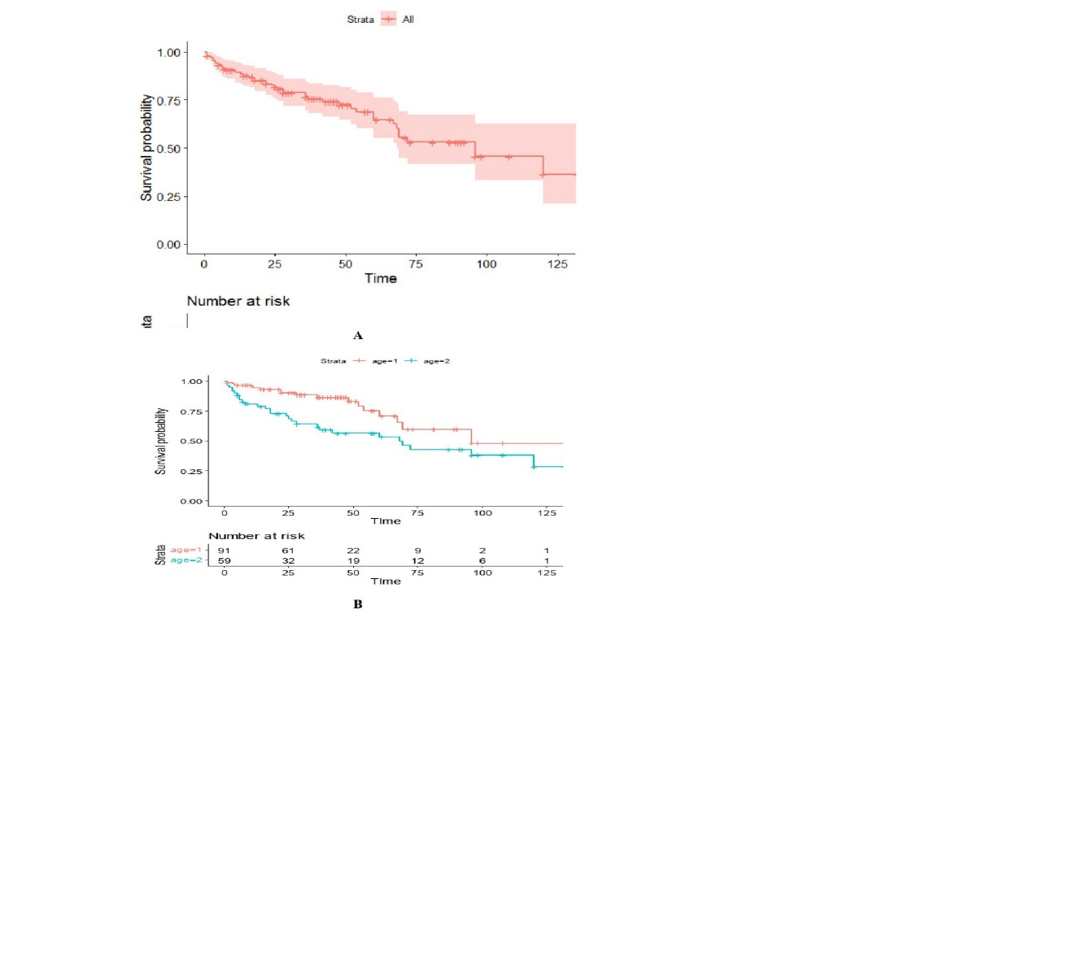 **[Figure 1.** Survival probability of OC patients (A) overall, (B) age at diagnosis(age=1, <60,age=2. >60)**]**

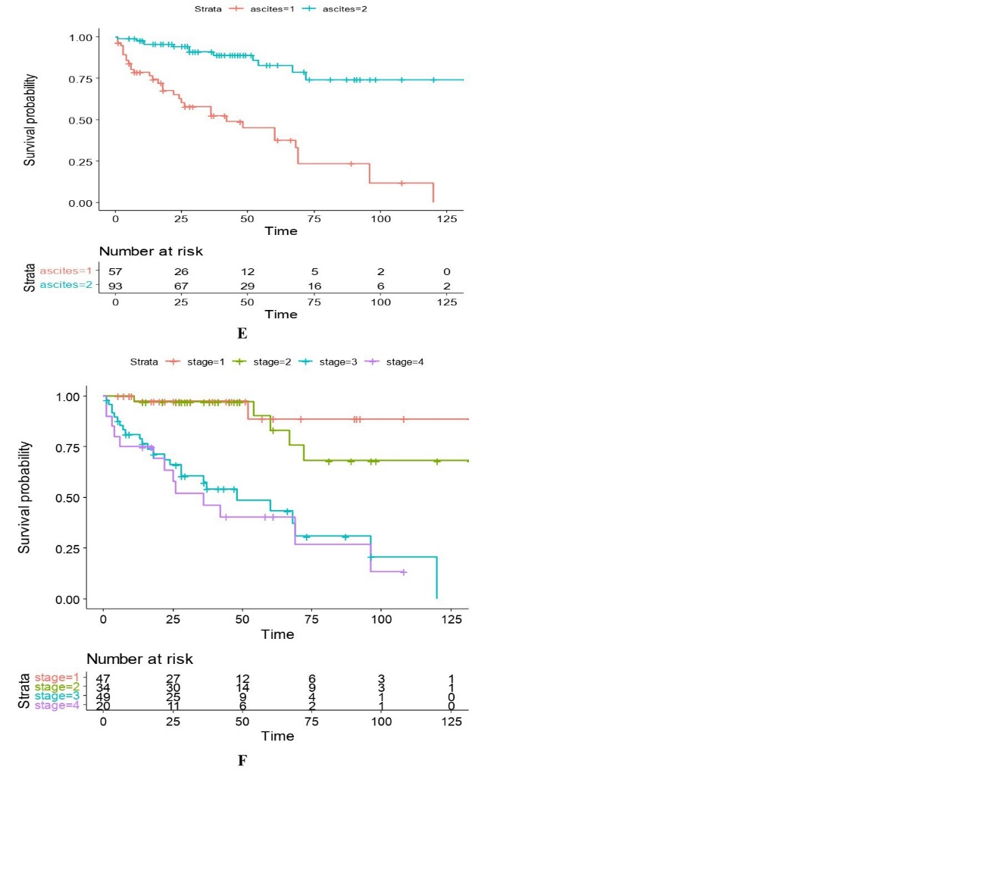

**[ Figure 2.** Survival probability of OC patients (F) stage disees(stage=1,I,Stage2=II,Stage=3,III,Stage=4.IV4, (E) ascites(ascite=1,yes,ascites=2.no)**]**

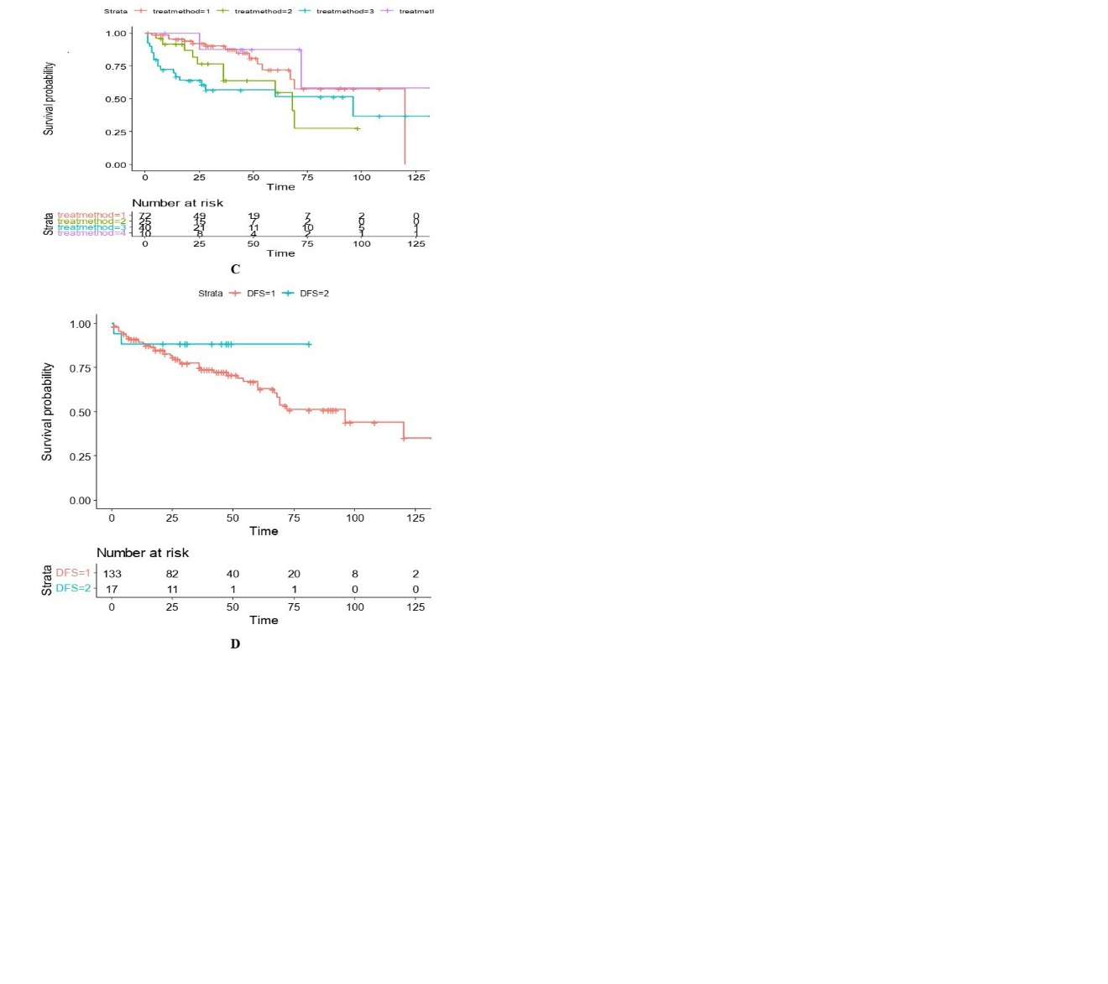

[**Figure3**. Survival probability of OC patients), (C) treatment metod(Surgery then chemotherapy=1, Chemotherapy then surgery=2, Surgery only=3, Chemotherapy only=, and (D(disease-free survival (dfs=1,<65,dfs=2,>65),Time(months)**]**