Fibonacci retracement and biological population growth

**R. Fallah-Moghaddam**

Department of Computer Science, Garmsar University

P. O. BOX 3588115589, Garmsar, Iran

 r.fallahmoghaddam@fmgarmsar.ac.ir

***Abstract*— *Today, the basics of technical analysis are widely used to study trends that have oscillating movements. For example, economics, financial markets, etc. are examples of these trends. One of the most important and widely used tools in technical analysis is Fibonacci ratios. In fact, Fibonacci ratios are used to determine the support and resistance points in predicting the future trend of a chart. Due to the very good behaviors that have been observed from these ratios in predicting the trend so far, we expect their application to be seen in natural and biological processes as well. In this article, we examined the birth trend in the last one hundred years in Iran. We tried to find the maximum and minimum points of birth in this process. We also tried to examine how Fibonacci ratios work on the birth rate in the last hundred years in Iran. To examine this, three main time periods were examined. 1320 to 1359, 1359 to 1379 and 1379 to 1394. Eventually as expected, It was observed that Fibonacci ratios had a significant effect on determining the points of support and resistance in the birth chart recorded in the last one hundred years in Iran.***

***Keywords—*** ***Fibonacci retracement, Population Bio-math, Born in Iran, Technical analysis.***

**Introduction**

Population growth is also related to the Fibonacci series.  In 1202, Leonardo Fibonacci investigated the question of how fast rabbits could breed under ideal circumstances.  Here is the question that he posed:

Suppose a newborn pair of rabbits, one male and one female, is put in the wild. The rabbits mate at the age of one month. At the end of its second month, a female can produce another pair of rabbits. Suppose that the rabbits never die and that each female always produces one new pair, with one male and one female, every month from the second month on.  How many pairs will there be in one year?

Fibonacci (c. 1170 – c. 1240–50)  was an [Italian](https://en.wikipedia.org/wiki/Italians) [mathematician](https://en.wikipedia.org/wiki/Mathematician) from the [Republic of Pisa](https://en.wikipedia.org/wiki/Republic_of_Pisa), considered to be "the most talented Western mathematician of the [Middle Ages](https://en.wikipedia.org/wiki/Middle_Ages)". Fibonacci popularized the [Hindu–Arabic numeral system](https://en.wikipedia.org/wiki/Hindu%E2%80%93Arabic_numeral_system) in the Western world primarily through his composition in 1202 of [Liber Abaci](https://en.wikipedia.org/wiki/Liber_Abaci) (Book of Calculation). He also introduced Europe to the sequence of [Fibonacci numbers](https://en.wikipedia.org/wiki/Fibonacci_number), which he used as an example in Liber Abaci.

In mathematics, the Fibonacci numbers, denoted by $F_{n}$ , form a [sequence](https://en.wikipedia.org/wiki/Integer_sequence), called the Fibonacci sequence, such that each number is the sum of the two preceding ones, starting from 0 and 1. That is, $F_{0, }=0, { F}_{1, }=1, { F}_{n }=F_{n-1 }+ F_{n-2 } for n > 1.$

The beginning of the sequence is thus

$$\left\{0,1,1,2,3,5,8,13,21,34,55,89,144,…\right\}.$$

In 1969, Parberry posed and solved an interesting problem in population growth analogous to the rabbit problem considered by Fibonacci. Liber Abaci posed and solved a problem involving the growth of a population of rabbits based on idealized assumptions. The solution, generation by generation, was a sequence of numbers later known as [Fibonacci numbers](https://en.wikipedia.org/wiki/Fibonacci_number). Although Fibonacci's Liber Abaci contains the earliest known description of the sequence outside of India, the sequence had been described by Indian mathematicians as early as the sixth century.

There is a strong relation between Fibonacci numbers and golden ratio, where

[Johannes Kepler](https://en.wikipedia.org/wiki/Johannes_Kepler) proved that $\lim_{n→∞}{\frac{F_{n+1}}{F_{n}}}=φ$.

For more result, see [1, 2, 3,6].

N. Rivier and his collaborators ([10]) modelized natural phyllotaxis by the tiling by Voronoi cells of spiral lattices formed by points placed regularly on a generative spiral. Locally, neighboring cells are organized as three whorls or parastichies, labeled with successive Fibonacci numbers. The structure is encoded as the sequence of the shapes (number of sides) of the successive Voronoi cells on the generative spiral. Fibonacci spiral patterns were produced artificially ([4,5]) by manipulating the stress on inorganic microstructures made of a silver core and a silicon dioxide shell. It was found that an elastically mismatched bi-layer structure may cause stress patterns that give rise to Fibonacci spirals. Results suggest that plant patterns might be modeled by mutually repulsive entities for both spherical and conical surfaces. It is conjectured that Fibonacci spirals are the least energy configuration on conical supports.

**Main Section**

Fibonacci numbers can be used to study models of population growth that always increase over time. In this model, we start with a pair of rabbits. If we pay attention, the human population also begins with a pair of people created by Alloh SWT, namely Adam and Eve. Both of them also always gave birth to a pair of twins, male and female. However, the process of increasing human population is not the same as the process of increasing Fibonacci rabbits. The last descendants of Adam and Eve were single, not twin.

From these rules, a pair of rabbits will have offspring in the third time unit. In the fourth time unit, the pair has $2$ pairs of offspring. Thus, in units of time , the number of pairs of offspring is $2-i$. The numbers on Fibonacci sequences indicate the number of rabbit pairs with a pair of rabbits meaning male and female. It is assumed at the beginning of the experiment (the first month) we have a pair of rabbits who are still babies. In the second month, the couple grew to become juvenils. In the third month, the rabbit has a pair of children (male and female). Each pair of rabbits will grow in the same pattern, namely infants, juvenils and adults. Each phase is passed in the same time interval, for example one month. By the time the couple becomes adults, each month will give birth to a pair of children. That is, a pair of rabbits that have entered the adult phase will give birth continuously every month. So, the baby bunny pair will give birth to a pair of children in the third, fourth, fifth month and so on. Thus, we have a population of Fibonacci rabbits consisting of three age groups according to the phases of rabbit growth, namely babies, juveniles and adults.

The Fibonacci sequence, and its “quantum” extension, can be found in genetic codes, including amino acids and codons ([9]). Deoxyribonucleic acid (DNA) in biological systems replicates with the aid of proteins. However, Kim et al. ([8]) have designed a controllable self-replicating system that does not require proteins. The self-assembly process into rings continues through two different replication pathways: one grows exponentially, the other grows according to Fibonacci's sequence.

Here we must mention an important point. Today, many charts are constantly growing and declining have a very complex relationship with Fibonacci numbers. In other words, the growth and decline of these graphs follow the Fibonacci ratios. Fibonacci ratios somehow determine the next step of a chart. There are many examples of this in economics, biology, financial markets, and so on.

The Fibonacci “ratios” are 23.6%, 38.2%, 50%, 61.8%, and 100%. These ratios show the mathematical relationship between the number sequences and are important to check the future trend of a chart.

For reasons that remain a mystery, Fibonacci ratios often display the points at which a trend of a chart reverses its current position.

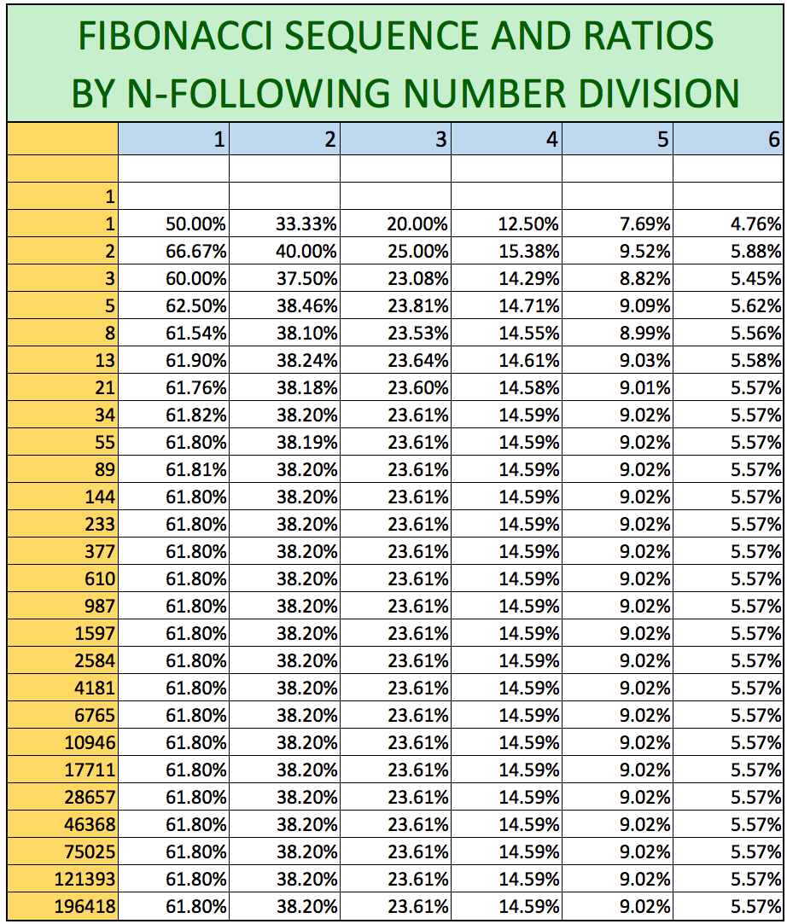

**Figure 1**. Fibonacci “ratios”

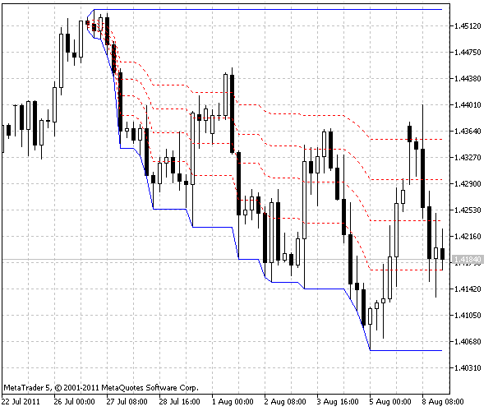

**Figure 2**. Fibonacci “ratios” and charts

Today, most of the trends that deal with growth and decline are closely related to Fibonacci inclusions. Note Figure (2). In a movement of growth and decline, you are always dealing with peaks and valleys. In fact, Fibonacci ratios are used to approximate these points. They can somehow limit the process of a chart. Population growth is one of the issues is always associated with growth and decline due to various factors.

In fact, the nature of population issues has a structure of the problem of hunting and hunter. This means that you are not always dealing with growth alone when considering the population of a species. Various factors in nature will sometimes lead to a decrease in even your sample population.

The chart below shows the number of people infected with the corona virus in several different countries over a period of time. As shown in the figure, due to various factors, the number of patients has never had a constant trend. Now the question is that:

Is it possible to use Fibonacci ratios that actually act as support and resistance lines on a chart to predict the future of a demographic trend.?

For more result, see [7, 11, 12].

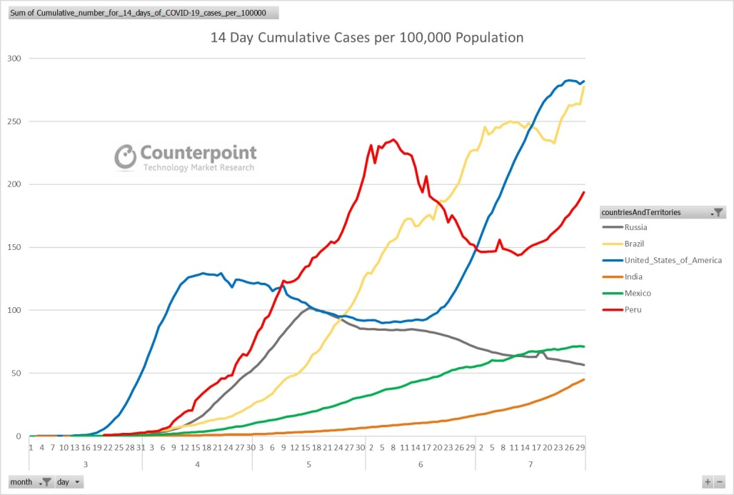

**Figure 3**. Graph of coronavirus infection in different countries.

Here we intend to examine the birth rate chart in Iran from 1338 to 1398. The statistics in the following tables are taken from the sites of official institutions. It is necessary to mention one point here. The official statistics on the birth rate are up to 1338. That means we do not have official statistics for that before. Maximum and minimum numbers are very important in examining Fibonacci ratios on a trend. It seems that the minimum birth rate in Iran is related to before 1338. This will definitely cause some confusion in our calculations. Because moving from one minimum point to the next maximum point will practically be the main criterion for the next calculations. However, even if you set a minimum local point in your process, again, calculations will be largely reliable.

**Table 1**. Birth rate chart in Iran from 1338 to 1398

|  |  |  |  |
| --- | --- | --- | --- |
| year | Birth amount | year | Birth amount |
| 1338 | 864846 | 1369 | 1726488 |
| 1339 | 876206 | 1370 | 1592898 |
| 1340 | 902260 | 1371 | 1433243 |
| 1341 | 957500 | 1372 | 1388017 |
| 1342 | 920967 | 1373 | 1426784 |
| 1343 | 1118911 | 1374 | 1205372 |
| 1344 | 1188346 | 1375 | 1187903 |
| 1345 | 1102848 | 1376 | 1179260 |
| 1346 | 1014321 | 1377 | 1186659 |
| 1347 | 1046134 | 1378 | 1174279 |
| 1348 | 1107910 | 1379 | 1095165 |
| 1349 | 1190957 | 1380 | 1110836 |
| 1350 | 1235025 | 1381 | 1122104 |
| 1351 | 1138843 | 1382 | 1171573 |
| 1352 | 1199777 | 1383 | 1154368 |
| 1353 | 1248256 | 1384 | 1239408 |
| 1354 | 1339267 | 1385 | 1253912 |
| 1355 | 1399977 | 1386 | 1286716 |
| 1356 | 1406204 | 1387 | 1300166 |
| 1357 | 1373738 | 1388 | 1348546 |
| 1358 | 1688942 | 1389 | 1364523 |
| 1359 | 2451765 | 1390 | 1382229 |
| 1360 | 2419951 | 1391 | 1421689 |
| 1361 | 2097957 | 1392 | 1471834 |
| 1362 | 2203560 | 1393 | 1534261 |
| 1363 | 2068279 | 1394 | 1570219 |
| 1364 | 2031969 | 1395 | 1528093 |
| 1365 | 2256971 | 1396 | 1487913 |
| 1366 | 1832722 | 1397 | 1366509 |
| 1367 | 1942936 | 1398 | 1205954 |
| 1368 | 1789817 |  |  |

As it is clear from the data in the table above, in 1338 and 1379 we have two absolute minimums. Also in 1359 and 1394, the maximums of the chart occur.

**Table 2**. Change in birth rate chart in Iran

|  |  |  |  |
| --- | --- | --- | --- |
| year | Change in birth amount | year | Change in birth amount |
| 1338-1359 | 1586919 | 1379-1394 | 475054 |
| 1359-1379 | 1356600 | 1394-1398 | 364265 |

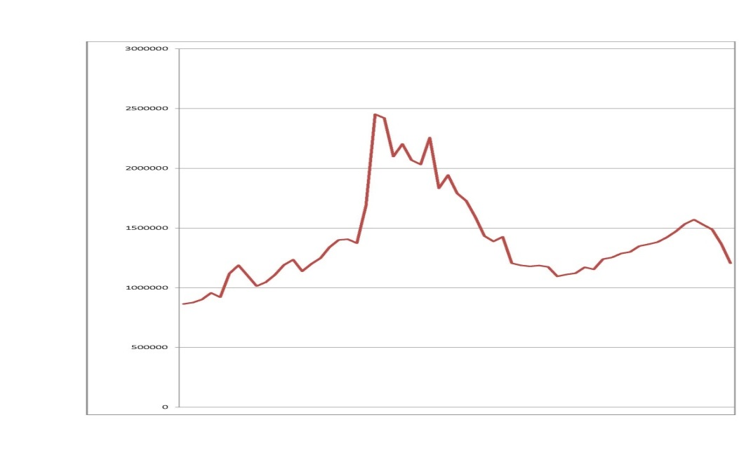

**Figure 4**. Birth rate chart in Iran from 1338 to 1398

Here is an important point. To use Fibonacci ratios, a chart must have accurate access to the maximum and minimum points. As can be seen from Table 1, in 1359 and 1394, the number of people born in Iran is at a maximum. Also in 1379, we have a minimum point in the chart process. But we must also be able to get the minimum number of people born before 1338. There are no official statistics on this. But it seems that the number of people born in 1338 is not a minimum. To find the minimum number of people born before 1338, we try to refer to historical evidence. In the last century, the outbreak of World War II has had many negative effects on the economic situation of the Iranian people. The living conditions of a family as well as the economic situation as well as health and treatment are very important issues that have a great impact on the birth process. Between 1320 and 1324, Iran was involved in the aftermath of World War II. Over these years, Iran has been plagued by famine, high inflation, and military strikes by foreign forces. Therefore, most likely, these years can be a reference for measuring the minimum point of birth rate. Certainly, given the military fires in Iran, one should not look for official birth census statistics. Therefore, in terms of time period, we consider the years 1320 to 1324 as the period of the lowest birth. Even if we make a mistake in this approximation, the mistake does notseems to make a big mistake in terms of numerical value. Life expectancy among Iranians in recent years has been between 72 and 75 years. Now it is enough to pay attention to the death statistics in the last ten years. According to official statistics, from 1390 to 1395, the death rate was almost constant at an average of 300,000. That is, we can consider the lowest number of births in the last century to be about the same number. Therefore, we consider the number of people born before 1338 to be approximately 300,000. On the other hand, the maximum number of births between 1320 and 1359 is related to 1359. Approximately 2,450,000 people have been born this year. The difference between the two numbers is approximately 2,150,000. On the other hand, in 1379, when the lowest birth rate occurred in the years 1359 to 1379, the birth rate is approximately equal to 1100,000 people. As a result, the rate of birth change between 1359 and 1379 is approximately equal to 1350000 people. According to the rules known in technical analysis for Fibonacci ratios, there is always a major correction in an uptrend. One of the important ratios in a corrective move is 0.618.

$$2150000×0.618=1330000$$

Therefore, the upward movement of birth in the years 1320 to 1359, has a corrective trend with the main ratio of Fibonacci (0.618). This downward movement occurred between 1359 and 1379. Now, if we consider the period of 1359 to 1379 as the main trend, the rate of birth change in these years has been about 1350000. After a downward movement between the years 1359 to 1379, in the years 1379 to 1394 we are facing an upward movement. The rate of birth change in the years 1379 to 1394 is approximately equal to 490,000 people.

$$1350000×0.38=513000.$$

Therefore, the birth trend in the years 1379 to 1394 with a ratio of 0.38, which is one of the main Fibo ratios, can be considered as a correction of the downward trend from 1359 to 1379.

Now a question is formed in the mind to conclude. If we consider the years 1379 to 1394 as an upward trend in birth, how many corrections will this move make?

In fact, the minimum birth rate in recent years can be what in a year. The birth rate change between 1379 and 1394 is about 490000 people. Given that the main Fibonacci correction ratios are usually one of the numbers 0.38, 0.5 and 0.618, the following situations will occur.

$$490000×0.38=186000.$$

$$490000×0.50=245000.$$

$$490000×0.618=303000.$$

But according to official statistics, the birth rate in 1399 was approximately equal to 1,100,000 people. Therefore, in terms of technical analysis, all three Fibonacci ratios are broken as trend support numbers. nd now we are at the 100% Fibo support point, which is usually one of the most important support factors in Fibonacci ratios. It seems to be a little hard to break. In this article, we tried to show how the basics of technical analysis, which are widely used in the world of economics and financial markets today, can affect biological phenomena and nature.

**ACKNOWLEDGEMENTS**

The author thanks the Research Council of the University of Garmsar for support.

**References**

1. A. T. Benjamin, N. T. Cameron, and J. J. Quinn (2007), Fibonacci determinants – A combinatorial approach, Fibonacci Quart. 45, 39–55.
2. A. T. Benjamin, N. T. Cameron, J. J. Quinn, and C. R. Yerger (2010), Catalan determinants – A combinatorial approach, Congr. Numer.: Proceedings of the Twelfth Conference on Fibonacci Numbers and their Applications 200, 27–34.
3. A. T. Benjamin and G. P. Dresden (2007), A combinatorial proof of Vandermonde’s determinant, Amer. Math. Monthly 114, 338–341.
4. L. Chaorong, Z. Xiaona, C. Zexian. (2005), Triangular and Fibonacci number patterns driven by stress on core/shell microstructures.” Science 309, 909.
5. L. Chaorong, J. Ailing, C. Zexian. (2007), Stressed Fibonacci spiral patterns of definite chirality, Applied Physics Letters 90, 164102.
6. E. Kilic, D. Tasci (2010), On the generalized Fibonacci and Pell sequences by Hessenberg matrices, Ars Combin. 94, 161–174.
7. E. Kilic, D. Tasci, P. Haukkanen (2010), On the generalized Lucas sequences by Hessenberg matrices, Ars Combin. 95, 383–395.
8. J. Kim, J. Lee, S. Hamada, S.Murata, S.Park (2015), Self-replication of DNA rings, Nature Nanotechnology 10, 528–533.
9. T. Négadi (2015), A Mathematical Model for the Genetic Code(s) Based on Fibonacci Numbers and their q-Analogues”, NeuroQuantology, Vol. 13, Issue 3, 259-272.
10. N. Rivier, J.F. Sadoc, J. Charvolin (2016), Phyllotaxis: a framework for foam topological evolution”, The European Physical Journal E, 39(1), 1-11.
11. R. P. Stanley (1997), Enumerative Combinatorics, Vol. I, Cambridge University Press.
12. W. Webb (1975), "Distribution of the First Digits of Fibonacci Numbers,*' The Fibonacci Quarterly, Vol. 13, No. 4, pp. 334-336.

نسبتهای فیبوناتچی و مساله رشد جمعیتهای بیولوژیک

**رضا فلاح مقدم**

گروه علوم کامپیوتر، دانشکده فنی و مهندسی، دانشگاه گرمسار، گرمسار، ایران

[r.fallahmoghaddam@fmgarmsar.ac.ir](mailto:r.fallahmoghaddam@fmgarmsar.ac.ir)

**چکیده: تحلیل تکنیکال یکی از علوم به روز شده مبتنی بر مفاهیم عمیق ریاضی است که در شاخه‌های متعدد علمی مثل اقتصاد، بازارهای مالی و ... کاربرد فراوانی دارد. در تحلیل تکنیکال ابزارهای متوعی استفاده می‌شود. یکی از ابزارهای بسیار مهم و کارساز در تحلیل تکنیکال نسبت‌های فیبوناتچی هستند. در حقیقت نسبت‌های فیبوناتچی برگرفته از نسبت‌های بین سری اعداد فیبوناتچی هستند. این نسبت‌ها به عنوان تعیین کننده نقاط حمایتی و مقاومتی در روند یک پدیده و جهت پیشگویی روند آن پدیده مورد استفاده قرار می‌گیرند. در اینجا سعی کردیم در یک بازه حدودا صد ساله، به بررسی میزان ولادت‌های ثبت شده در کشور ایران بپردازیم. این بازه، به سه بازه زمانی بین سال‌های 1320 تا 1359، 1359 تا 1379 و 1379 تا 1394 تقسیم شده است. مشاهده شده که نسبت‌های فیبوناتچی رفتار بسیار مناسبی در جهت پیش‌بینی نقاط حمایتی و مقاومتی یا به طور واضح‌تر نقاط ماکزیمم یا مینیمم روند ولادت در صد سال اخیر ایران دارند. این نگرش می‌تواند به استفاده از سایر ابزارهای تکنیکال بر روی فرآیندهای زیستی تعمیم یابد.**

**کلید واژگان:** ریاضیات زیستی، نسبت‌های فیبوناتچی، ولادت در ایران، جمعیت، تحلیل تکنیکال.