**Hawking Radiation for Hayward Black hole in Einstein–Gauss–Bonnet Gravity through Tunneling Process**

Shadi Shahraeini1, Kourosh Nozari2, Sara Saghafi3

1Department of Theoretical Physics, University of Mazandaran, Babolsar.

Email: s.shahraeini02@umail.umz.ac.ir

2Department of Theoretical Physics, University of Mazandaran, Babolsar.

Email: knozari@umz.ac.ir

3Department of Theoretical Physics, University of Mazandaran, Babolsar.

Email: s.saghafi@umz.ac.ir

**Abstract.** The Einstein-Gauss-Bonnet theory (EGB) can be considered as one of the most promising candidates for modified gravity. In this paper we intend to obtain the Hawking radiation of a 5-dimensional Hayward black hole with a regular center, having inner (Cauchy) and outer (event) horizons in EGB theory. We present a short derivation of Hawking radiation as a tunneling process, based on particles in a dynamical geometry. The imaginary part of the action for the classically forbidden process is related to the Boltzmann factor for emission at the Hawking temperature.

Keywords: Hawking radiation, Hayward Black holes, Einstein-Gauss-Bonnet Theory

**1 Introduction**

black holes are the exact solution of the Einstein’s general relativity, appear to exist in the universe, with singularities form inside them [1]. However, the existence of a singularity means space–time ceases to exist signaling the breakdown of general relativity, requiring modifications that believably include quantum theory. One of the steps in this direction, regular (i.e.non-singular) black holes have widely considered resolving the singularity problems, dating back to Bardeen [2] who gave first regular black hole model by Bardeen [2], according to whom there are horizons but there is no singularity. Hayward [3] proposed, Bardeen-like, regular space–times are given that describe the formation of a black hole from an initial vacuum region which has a finite density and pressure, vanishing rapidly at large small and behaving as a cosmological constant at a small distance. It is a simple exact model of general relativity coupled to electrodynamics and hence Hayward black hole has attracted significant attention in various studies, like Quasinormal modes of the black holes by Lin et al. [4], The geodesic equation of a particle by Chiba and Kimura [5], wormholes from the regular black hole [6,7] with their stability [8], black hole thermodynamics [9] and related properties [10,11], and strong deflection lensing [12]. The rotating regular Hayward’s metric has been studied as a particle accelerator [13,14].

In the last few decades, there has been a noteworthy number of attempts in higher dimensions gravity in order to understand the low-energy limit of string theory. The Einstein–Gauss–Bonnet gravity is a very important higher dimensional generalization of Einstein’s gravity which was suggested by Lanczos [15], and then rediscovered by David Lovelock [16]. The study of Einstein– Gauss–Bonnet theory becomes very important since it provides a broader setup to explore a lot of conceptual issues related to gravity. This theory is completely free of ghost and the order of the field equations in the Einstein–Gauss–Bonnet theory is no higher than two. Since their outset, there has been a lot of attempts to obtain the black hole solution, but Boulware and Deser were the first to obtain the exact black hole solution in the Einstein–Gauss–Bonnet gravity [17,18]. After that several exact black hole solutions with their thermodynamical properties have been discussed by various authors [19,20]. Several black hole solutions with matter source generalizing the Boulware–Desser solution have also been explored [21,22].

A natural question to ask: what is the effect of the Einstein–Gauss–Bonnet correction on the regular black holes and their properties? In order to answer this question, one would first need a regular solution for the Einstein–Gauss–Bonnet theory. In [23] they obtained a 5D spherically symmetric and static Hayward-like black hole solution of the Einstein–Gauss–Bonnet gravity. It turned out that the metric purposed there is an exact black hole model of Einstein–Gauss– Bonnet having minimal coupling with nonlinear electrodynamics thereby it is the generalization of the Boulware–Desser solution.

In this paper we aim to study the tunneling of the massless particles from the event horizon of 5D EGB-Hayward black holes and we will investigate the correlation between the emission modes and temperature of this horizon. This paper is organized as follows: In section 2, we have a short review of the structure of the 5D EGB-Hayward black holes with a regular center and two horizons. In section 3, we explain the tunneling process and illustrate the temperature of the 5D EGB-Hayward black holes. Section 4 contains a summary and conclusion.

**2 5D exact Hayward-like black holes in EGB gravity**

The general relativity with minimal coupling with nonlinear electrodynamics leads to exact spherically symmetric regular black holes [24,25,26,27]. The two most famous exact black holes are Bardeen [2] and Hayward [3] regular black holes. Here, we are interested in the Hayward-like black hole solution with a regular center in the EGB gravity in 5D space-time. we use the metric ansatz [28]:

$$ds^{2}=-f\left(r\right)dt^{2}+\frac{dr^{2}}{f\left(r\right)}+r^{2}{dΩ}_{3}^{2} , (1)$$

Where ${dΩ}_{3}^{2}={dθ}^{2}+\sin^{2}θ({d∅}^{2}+\sin^{2}∅{dΨ}^{2}$) is the metric in the 3D hypersurface with volume $V_{3}$ and f(r) is the metric function:

$f\left(r\right)=1+\frac{r^{2}}{4α}(1±\sqrt{1+\frac{8αm}{r^{4}+e^{4}}} )$ (2)

Here, m is a constant of integration having the relation with the Arnowitt-Deser-Misner (ADM) mass M of the black hole with the relation of

$M=\frac{3V_{3}}{k_{5}}m$ (3)

Here, $V_{3}$ is the volume of a 3-dimensional unit sphere and the metric has a coordinate singularity at the horizon. It is found that, when m $≠$ 0 $≠$ α, the invariants are well behaved everywhere including at r = 0. Thus, the 5D Hayward like black holes have no singularity or they are regular. It turns out that $g^{rr}=f\left(r_{H}\right)=0$ is only coordinate singularity implies the presence of horizons. After some calculations, the location of horizon is

$r_{+}^{2}=\frac{1}{3}\left[m-2α-\frac{2^{\frac{2}{3}}\left(3e^{4}-{\left(m-2α\right)}^{2}\right)+β^{2}}{2^{\frac{1}{3}}β}\right]$ (4)

with

$β=2{\left(m-2α\right)}^{2}+12mα^{2}-18\left(m+4α\right)e^{4}+ \sqrt{{(2{\left(m-2α\right)}^{2}+12mα^{2}--18\left(m+4α\right)e^{4})}^{2}+4{((3e^{4}-\left(m-2α\right))}^{3}}$ (5)

It is possible to keep the value of mass $m$ and coupling constant $α$ fixed, then we come to find out that there exists a critical value of charge ($e_{E}$), such that the Cauchy ($r_{-}$) and the event horizons ($r_{+}$) coincide, i.e., $r_{-}=r_{+}$, corresponds to the extremal 5D EGB-Hayward black holes with degenerate horizon radius ($r_{E}=r_{±}$). So, when $e<e_{E}$, black holes with Cauchy and event horizons exist and for any value of charge $e>e_{E}$, there exists only a regular space–time but not black holes.

**3 Hawking Radiation of the 5D EGB-Hayward Black holes** **with Tunneling Process**

In the intelligent approach that Parikh and Wilczeck have provided two issues are considerable: energy conservation and dynamical geometry [30-32]. In this picture, particle, and antiparticle are created with zero total energy in the near of one side of the horizon, after that one particle tunnels from the horizon in a semiclassical way. A particle tunnels through a barrier created by the particle’s energy itself. As a result, the radius and mass of the black hole reduce as much as the particle of energy $ω$. The first step to the calculation of particle tunneling is the construction of the nonsingular line element on the horizon. To resolving horizon singularity, we use the Painlevé coordinate transformation with definition $t_{p}$ by $t_{p}=t-f(r)$. Applying this transformation on the metric (1), we will have a new nonsingular coordinate as follows

${ds}^{2}=-f\left(r\right){dt}^{2}+2\sqrt{1-f\left(r\right)}drdt+{dr}^{2}+r^{2}{{dΩ}_{3}}^{2}$ (6)

Now, we present the primary calculation of the temperature of the black hole with the tunneling process. A particle is moving from an initial state in $r_{in}$ to the final state in $r_{out}$ as $r_{in}>r_{out}$. Tunneling calculation based on to account the imaginary part of the action for this particle as follows

$Im S=Im\int_{r_{in}}^{r_{out}}{p_{r}dr=Im\int_{r_{in}}^{r_{out}}{\int_{0}^{p_{r}}{{dp}_{r}^{'}dr}}}$ (7)

where $r_{in}=r_{H}-ϵ$ and $r_{out}=r_{H}+ϵ$, $\tilde{ω}$ is particles’ energy which is known as a self- interaction. Putting Hamilton equation, ${dp}_{r}=\frac{dH}{\dot{r}}$, on the Eq. (7), we have

$I=\int_{r_{in}}^{r_{out}}{\int_{M}^{M-ω}{\frac{dr}{ṙ}dH=\int_{0}^{ω}{\int_{r_{in}}^{r_{out}}{\frac{dr}{ṙ}\left(-d\tilde{ω}\right)}}}}$ (8)

Because we note the massless particles’ tunneling, we determine the light-like geodesics regarded to transformed metric (Eq. (6)) as follows

$ṙ=±1-\sqrt{1-f(r)}$ (9)

where $+$ and $-$ signs indicate the outgoing and ingoing geodesics, respectively. With considering outgoing trajectories and substituting Eq. (9) in Eq. (8), we find the imaginary part of the action as follow

$ImS=-Im∫_{0}^{ω}∫_{r_{in}}^{r_{out}}\frac{dr d\tilde{ω}}{1-\sqrt{1-f(r)}}$ (10)

In the tunneling process, since it is a near horizon phenomenon, particles created near the inside of black hole horizon are located at $r_{in}=r_{+}$, then these tunnel from black hole horizon and reach the outside of it which is located at $r_{out}=\frac{1}{3}{[(m-ω)-2α-\frac{2^{\frac{2}{3}}\left(3e^{4}-{\left(\left(m-ω\right)-2α\right)}^{2}\right)+β^{2}}{2^{\frac{1}{3}}β}]}^{\frac{1}{2}}$, where $ω$ is the particle’s shell of energy. To calculate the imaginary part of the action, we replace Eq. (2) in Eq. (10), as follows

$ImS=-Im∫_{0}^{ω}∫_{r_{in}}^{r_{out}}\frac{dr d\tilde{ω}}{1-\sqrt{\frac{r^{2}}{4α}(1±\sqrt{1+\frac{8αm}{r^{4}+e^{4}}} )}}$ (11)

This integral has two poles, so, to deduce the poles we expand the denominator in terms of $r_{out}$ as follows

$ṙ=1-\sqrt{1-\left[f\left(r_{out}\right)+f^{'}{(r}_{out}\right)\left(r-r_{out}\right)-…}$ (12)

where a prime indicates derivative with respect to r. we compute the first integral with residue calculus and expand the result to the second order of $ω$. Calculating the second integral, we derive the imaginary part of the action in terms of particles’ energy and the black hole mass. According to the relation between the emission rate, the imaginary part of the action, and the Boltzmann factor

$Γ≃e^{-2ImS}=e^{-βω}$ (13)

the temperature of the black hole can be calculated since the Hawking temperature is the inverse of the Boltzmann factor, $T=\frac{1}{β}$. Finally, we derive the temperature of the black hole horizon in terms of the black hole mass and the coupling constant. We plot the temperature of the black hole horizon of the 5D exact Hayward-like black holes in EGB gravity as a function of the mass of the black hole in Fig. (1) with $α=0.1,0.2,0.4,0.6$. By reducing the mass of the black hole, the temperature increases to a maximum temperature when the black hole mass reaches a special mass. After, reducing mass, the temperature reduces, too. On the other hand, by reducing the coupling constant, maximum temperature of the black hole horizon increases. For comparison, we plotted the standard hawking temperature. It is clear that in the final stage of evaporation the standard Hawking temperature goes to infinity and is divergent but for this 5D EGB-Hayward black hole, the presence of coupling constant leads to have a zero temperature at the final stage of evaporation.

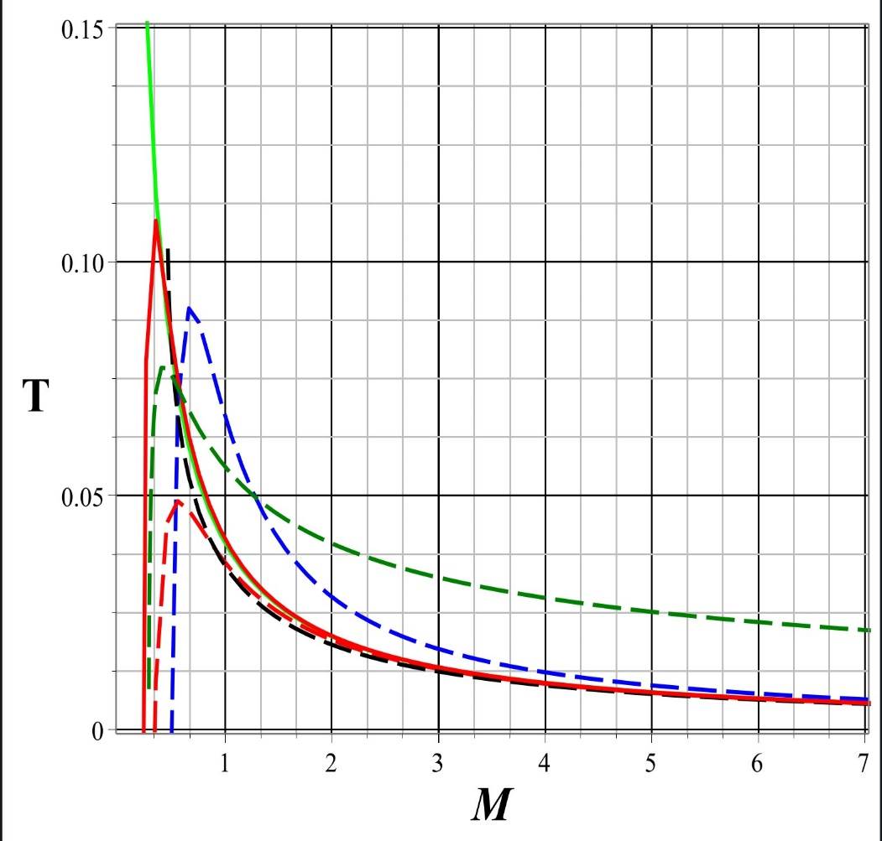

Fig (1): Temperature of the 5D exact Hayward-like black holes in EGB gravity versus Mass. The figure has been plotted with $α=0.1,0.2,0.4,0.6$ from up to down. The green plot is for standard Hawking temperature for Schwarzschild black hole

**4 Conclusions**

In this work, we investigated the 5D exact Hayward-like black hole in EGB gravityand their radiation and temperature. We calculated the tunneling of the massless particles from the event horizon of 5D EGB-Hayward black hole and we investigated the temperature of this horizon. The temperature of the black hole horizon of the 5D exact Hayward-like black hole in EGB gravity was plotted as a function of the mass of the black hole in Fig. (1) with $α=0.1,0.2,0.4,0.6$. By reducing the mass of the black hole, the temperature increases to a maximum temperature when the black hole mass reaches a special mass. After, reducing mass, the temperature reduces, too. On the other hand, by reducing the coupling constant, maximum temperature of the black hole horizon increases. We concluded that in the final stage of evaporation the standard Hawking temperature goes to infinity and is divergent but for this 5D EGB-Hayward black hole, the presence of coupling constant leads to have a zero temperature at the final stage of evaporation.

**References**

[1] S. W. Hawking and G. F. R. Ellis, The Large Scale Structure of Spacetime (Cambridge University Press, Cambridge, 1973).

[2] J. Bardeen, in Proceedings of GR5, Non-singular general-relativistic gravitational collapse

(Tiflis, U.S.S.R., 1968).

[3] S. A. Hayward, Formation and Evaporation of Nonsingular Black Holes

Phys, Rev. Lett. 96, 031103 (2006).

[4] K. Lin, J. Li and S. Yang, Quasinormal modes of gravitational field perturbation of regular phantom black holes, Int. J. Theor. Phys. 52, 3771 (2013).

[5] T. Chiba and M. Kimura, A note on geodesics in the Hayward metric, PTEP 2017, no. 4, 043E01 (2017).

[6] M. Halilsoy, A. Ovgun and S. H. Mazharimousavi, Thin-shell wormholes from the regular Hayward black hole, Eur. Phys. J. C 74, 2796 (2014).

[7] P. K. F. Kuhfittig, Aditi J. Math, Hayward black holes in the novel $4D$ Einstein-Gauss-Bonnet gravity, Phys. 5, 25 (2014).

[8] M. Sharif and S. Mumtaz, Stability of the Regular Hayward Thin-Shell Wormholes, Adv. High Energy Phys. 2016, 2868750 (2016).

[9] R. V. Maluf and Juliano C.S, Thermodynamics of a class of regular black holes with a generalized uncertainty principle, Neves Phys. Rev. D 97, 104015 (2018).

[10] A. Abdujabbarov, M. Amir, B. Ahmedov and S. G. Ghosh, Shadow of rotating regular black holes, Phys. Rev. D 93, 104004 (2016).

[11] S. H. Mehdipour and M. H. Ahmadi,Black Hole Remnants in Hayward Solutions and Noncommutative Effects, Nucl. Phys. B 926, 49 (2018).

[12] S. S. Zhao and Y. Xie, Strong deflection gravitational lensing by a modified Hayward black hole, Eur. Phys. J. C 77, 272 (2017).

[13] B. Gwak, Collision of two rotating Hayward black holes, Eur. Phys. J. C 77, 482 (2017).

[14] M. Amir and S. G. Ghosh, Horizon structure of rotating Bardeen black hole and particle acceleration, JHEP 1507, 015 (2015).

[15] C. Lanczos, A Remarkable Property of the Riemann-Christoffel Tensor in Four Dimensions, Ann. Math. 39, 842 (1938).

[16] D. Lovelock, The Einstein Tensor and Its Generalizations, J. Math. Phys. (N.Y.) 12, 498 (1971).

[17] D. G. Boulware and S. Deser, String-Generated Gravity Models, Phys. Rev. Lett. 55, 2656 (1985).

[18] R. C. Myers and J.Z. Simon, Black-hole thermodynamics in Lovelock gravity, Phys. Rev. D 38, 2434 (1988).

[19] Y. M. Cho and I.P. Neupane, Anti-de Sitter Black Holes, Thermal Phase Transition and Holography in Higher Curvature Gravity**,** Phys. Rev. D 66, 024044 (2002).

[20] C. Sahabandu, P. Suranyi, C. Vaz and L.C.R.Wijewardhana, Thermodynamics of static black objects in D dimensional Einstein-Gauss-Bonnet gravity with D−4 compact dimensions, Phys. Rev. D 73, 044009 (2006).

[21] S. H. Mazharimousavi and M. Halilsoy, Lovelock black holes with a power-Yang–Mills source, Phys. Lett. B 681, 190 (2009).

[22] S. G. Ghosh and S. D. Maharaj, Cloud of strings for radiating black holes in Lovelock gravity, Phys. Rev. D, 89, 084027 (2014).

[23] A. Kumar, D. Singh and S. Ghosh, Hayward black holes in Einstein–Gauss–Bonnet gravity, Annals of Physics 419 (2020) 168214

[24] I.G. Dymnikova,DE SITTER-SCHWARZSCHILD BLACK HOLE: ITS PARTICLELIKE CORE AND THERMODYNAMICAL PROPERTIES, Int. Journal of Mod. Phys. D, 5 529 (1996).

[25] I. G. Dymnikova, Micha Korpusik, Regular Black Hole Remnants, Phys. Lett. B 685, 1218 (2010).

[26] E. Ayon-Beato and A. Garcia, Non-Singular Charged Black Hole Solution for Non-Linear Source, Gen. Rel. Grav. 31, 629 (1999).

[27] E. Ayon-Beato, A. Garcia,The Bardeen Model as a Nonlinear Magnetic Monopole, Phys. Lett. B 493, 149 (2000).

[28] S. G. Ghosh and S. D. Maharaj, Radiating Kerr-like regular black hole, Eur. Phys. J. C 75, 7 (2015).

[29] I. Perez-Roman and N. Brent, Gen. Rel. Grav. 50, no. 6, 64 (2018).

[30] M. K. Parikh and F. Wilczek, Hawking Radiation as Tunneling, Phys. Rev. Lett. 85, 5042 (2000), [hepth/9907001].

[31] M. K. Parikh, A Secret Tunnel Through The Horizon, Int. J. Mod. Phys. D 13, 2351 (2004), [hepth/0405160]; M. K. Parikh, Energy Conservation and Hawking Radiation, (2004) [arXiv: hep-th/0402166].

[32] P. Kraus, F. Wilczek, Self-Interaction Correction to Black Hole Radiance, Nucl. Phys. B 433, 403 (1995), [gr-qc/9408003].