**Investigation of Stability Zones for Internal Kink Mode in IR-T1 Tokamak**

Fatemeh Nabizadeh, Ahmad Naghidokht

School of Physics, Damghan University, Damghan, Iran.

Email: fatemehnabizadeh98@gmail.com

Email: ahmadnaghidokht@gmail.com

**Abstract.** Internal kink mode has been considered as an effective factor in disruptions and according to this issue, its stability in IR-T1 tokamak (circular cross-section plasma) has been investigated. Tokamak plasma stabilization against this mode is provided by a suitable profile for the safety factor. By considering a common profile for toroidal current density, corresponding profiles for the safety factor and growth rate of the internal kink instability were obtained for IR-T1 tokamak. The results show the highest stability in the plasma boundary regions for all $ν$ values ​​and the highest instability in the central plasma regions for values ​​of $ν$ > 3. Also, comparing between these results with the findings of data fitting with one of the main codes in the field of this instability, shows a good agreement for the order of growth rate of instability.

Keywords: Magnetohydrodynamic stability, Safety factor, Internal kink mode, IR-T1 tokamak.

**1 Introduction**

Plasma instability remains a major obstacle to the magnetic confinement fusion approach in a nuclear reactor, especially large-scale magnetohydrodynamic (MHD) modes that can have the most destructive effects on stability. The role of the ideal MHD model is to study the equilibrium and stability properties of different structures for the continuous operation of nuclear fusion energy extraction structures, especially magnetic fusion energy. Even if the magnetic field settings of the structures are in accordance with the ideal MHD theory, perturbation is still possible, so achieving MHD stability is essential. Non-ideal effects such as limited resistance, thermal conductivity and viscosity may lead to instabilities that are weaker than what is allowed by the ideal MHD [1,2]. Anyway, the turbulence caused by MHD instabilities can be in any form, but the resonance will occur for instabilities that have surfaces with definite $q=\frac{m}{n}$ and produce certain modes of instability. The numbers $m$ and $n$ are used to indicate the poloidal and the toroidal mode. The stability of the tokamak plasma in these modes is provided by the safety factor $q$ [3, 4].

Kink modes lead to convexity and concavity in magnetic field lines, resulting in their fracture. This is followed by magnetic islands, which destroy the stability of the magnetic flux lines and cause the plasma to become unstable. Internal kink mode ( $n$ = 1, $m$ =1) is considered as a direct cause or at least an important component in the dynamics of sawtooth oscillations in tokamak, which causes disruptions and consequently catastrophic loss of plasma control [5, 6]. The growth rate of this mode depends to a large extent on the $q$ profile, so that a very small change in $q$ may destabilize the stable equilibrium. Analytical and numerical calculations related to the growth rate in the ideal and the resistance mode in TCV tokamak [7, 8] have studied these effects. In an NSTX species plasma, internal kink has been investigated in the presence of pure toroidal flow [9]. This mode is also one of the MHD instabilities in common discharge scenarios in ASDEX-U tokamak [10,11]. Studies related to this magnetohydrodynamic mode and its stability have also been performed in Damavand tokamak [12]. In this work, we will study the stability regions for the internal kink mode in IR-T1 tokamak, a small ohmic tokamak with an air core, copper-free shell, and circular cross-section plasma.

**2 The Growth Rate of Internal Kink Instability**

The basic variable characterizing stability, $q(r)$, is related to the toroidal current distribution. Radial profile of the safety factor $q(r)$ usually has its minimum value inside or near the magnetic axis and increases outwards. At high aspect ratio and circular cross section plasma, the behavior is simply determined as follows:

$q\left(r\right)=\frac{2πr^{2}B_{φ}}{μ_{0}R_{0}I_{p}}=\frac{{rB}_{φ}}{R_{0}B_{θ}}$ (1)

Where $B_{φ}$, $B_{θ}$, $R_{0}$ and $I_{p}$ are toroidal field, poloidal field, major radius and plasma current, respectively. For the following current distribution ( $a$ is minor radius of plasma and $ν=1,2,3,4,5$):

$j_{ϕ}\left(r\right)=j_{ϕ0}(1-\frac{r^{2}}{a^{2}})^{ν}$ (2)

Next, using Maxwell equations, the poloidal magnetic field profile is given as:

$B_{θ}=\frac{μ_{0}j_{ϕ}\left(0\right)a^{2}}{2\left(ν+1\right)r}(1-{\left(1-{r^{2}}/{a^{2}}\right)}^{ν+1}) r≤a$ $B_{θ}=\frac{μ_{0}j_{ϕ}\left(0\right)a^{2}}{2\left(ν+1\right)r}(1-{\left(1-{r^{2}}/{a^{2}}\right)}^{ν+1}) r≤a$

$B_{θ}=\frac{μ_{0}j_{ϕ}\left(0\right)a^{2}}{2\left(ν+1\right)r} a<r<b$ (3)

Finally, the radial profile of the safety factor will be obtained from Eq. (1) [13]:

$q\left(r\right)=\frac{{2πa}^{2}}{μ_{0}I_{p}}\frac{B_{φ} {r^{2}}/{a^{2}}}{R_{0}\left[1-{\left(1-{r^{2}}/{a^{2}}\right)}^{ν+1}\right]}$ (4)

We are now looking to calculate the growth rate of internal kink instability. For this purpose, we will consider a very simple zero pressure cylindrical equilibrium with nearly constant current in the $z$ direction. The plasma is contained in the region $r<a$ and the wall at $r=b$ is considered perfectly conducting. The region between $r=a$ and $r=b$ is the vacuumregion. The magnetic field is obtained as follows:

$B_{0}=\left(B_{0}+B_{2}\left(r\right)\right)\hat{z}+B_{θ}\left(r\right)$ (5)

Where $B_{0}$ is the dominant toroidal field in a tokamak and $r$ is radius of the cylinder. Pushing the plasma a small distance away from its equilibrium state, the momentum equation becomes:

$ρ_{0}\frac{∂^{2}ξ }{∂t^{2}}=J_{0}×δB+\left(∇×δB\right)×B_{0}=F\left(ξ\right)$ (6)

Where $ξ$ and $ρ_{0}$ are the plasma displacement (∂ $ξ$/ ∂t = **v**) and the plasma density. Outside the plasma the vacuum field is perturbed and produces a pressure on that region. In order to matching the magnetic pressure inside and outside of the plasma, a small compressive component must be added to the plasma displacement, the magnitude of which will be determined by matching the pressure at the boundary between the plasma and the vacuum. Also, the absence of any field in the region between plasma and vacuum should be considered. Finally, the momentum equation is as follows:

$ρ_{0}\frac{∂^{2} ξ_{0}}{∂t^{2}}=F\left(ξ\right)=\frac{2B_{0}^{2} }{μ_{0}qR_{0}^{2}}\frac{\left(\frac{b^{2}}{a^{2}}-\frac{1}{q}\right)}{\left(\frac{b^{2}}{a^{2}}-1\right)}\left(\frac{1}{q}-1\right)ξ_{0}$ (7)

where $ξ=ξ_{0}$ is considered. When $1>q>(\frac{a^{2}}{b^{2}})$, we will have an internal kink instability with the following growth rate [14]:

$γ=\sqrt{\frac{2B_{φ}^{2} }{μ_{0}ρ_{0}qR_{0}^{2}}\frac{\left(\frac{b^{2}}{a^{2}}-\frac{1}{q}\right)}{\left(\frac{b^{2}}{a^{2}}-1\right)}\left(\frac{1}{q}-1\right)}$ (8)

Now, by providing characteristic data of IR-T1 tokamak in Table 1, the safety factor profiles and growth rate will be calculated.

Table 1. Characteristic data of IR-T1 tokamak [13].

|  |  |
| --- | --- |
| IR-T1 Tokamak | Parameters |
| 45 cm | $$R$$ |
| 12.5 cm | $$a$$ |
| 15 cm |  |
| 0.75 T |  |
| m-3 |  |
| 32.5 kA |  |

**3 Simulations and Results**

In this section, we present growth rate and safety factor profiles, equations (4) and (8), in Figs. 1 and 2, to evaluate the stability of this mode in the IR-T1 tokamak. This is done entirely through programming in MATLAB software and its tools.

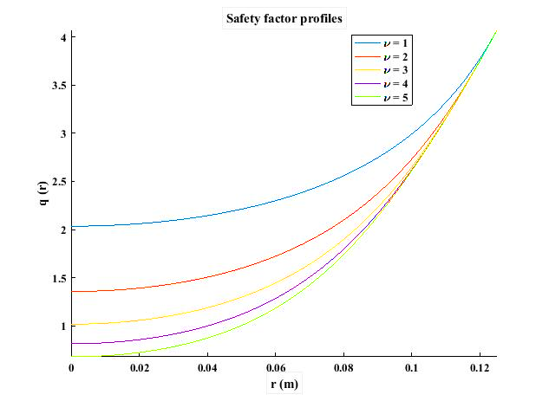

Figure 1. The safety factor profile by eq. (4) in IR-T1 tokamak.

In Fig. 1, with $ν$ increasing the value of $q$ decreases. Because $q>$ 1 is the minimum condition for the stability of the internal kink mode, then for $ν=1,2,3$ the plasma will be stable against this mode in all regions. For $ν=4$ and $ν=5$ in some areas, especially in the more central areas of the plasma, $q<$ 1 and the stability, albeit locally, will be lost which can be linked to the sawtooth instability and cause plasma loss. It can be seen that at the plasma boundary ($r=a$), all values ​​of $q$ tend to the same value ($q(a)\sim 3.9$) while at the center of the plasma they have different values ​​(from 0.68 to 2.06). Using the safety factor profile obtained in Fig. 1, the desired growth rate for IR-T1 tokamak was calculated through equation (8) and the results are presented in Fig. 2. As can be seen, for $ν=1,2,3$ the real part (indicating instability) has no value in all areas and shows no instability. The imaginary part (indicating stability) is almost constant for $ν=1$ and has the highest value but for $ν=2$ and $ν=3$, it is changing so that it has the lowest value in the center and the highest value near the plasma boundary. For $ν=4$,5 the real part has the highest value in the central areas, which indicates the growth of instability. Reflecting on the results, for all $ν$ values, we see the highest mode stability near the IR-T1 plasma boundary. Another point is the instability overlap of values $ν=4 and 5$ ​​in a specific part of the central plasma region, which allows instability to occur in that part for both values. Finally, it can be seen that for all values, $q(a)\sim 4$ and this value has already been confirmed in reference [15].



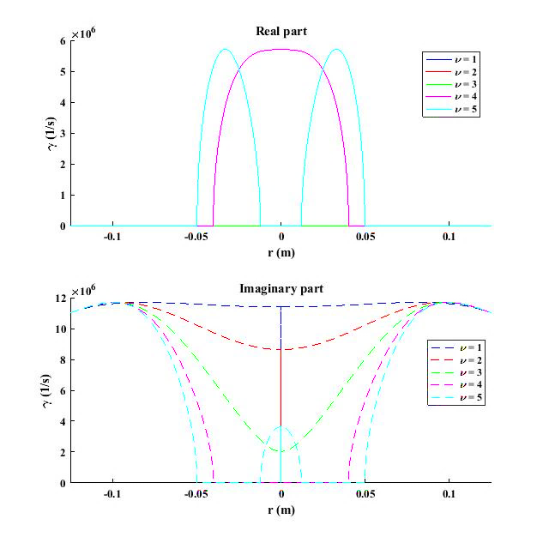

Figure 2. The growth rate of internal kink instability (Real part of eq. (8)) and Imaginary, or stable, part of eq. (8) for this mode in IR-T1 tokamak for values $ν=1,2,3,4,5$.

The internal kink mode is a pure toroidal mode, so it will be possible to study the growth rate of this pressure gradients-driven mode by analyzing the poloidal beta profile. This is done using one of the most up-to-date related codes, KINX. One of the obtained relationships for the growth rate of internal kink instability, which is approved and used in a wide range of plasma parameters in different tokamaks, has been obtained by fitting experimental data with KINX analytical code as follows [16]:

$γτ_{A}=0/44 \frac{ϵ_{1}κ_{1}}{1+7 ϵ_{1}s_{1}}(β_{p1}-β_{p}^{c})$ (9)

$β_{p}^{c}=0.9-\left(0.6+0.1 s\left(r\right)\right)κ_{1}$ (10)

$s\left(r\right)=\frac{r}{q\left(r\right)}\frac{dq\left(r\right)}{dr}$ (11)

In these relations, index 1 is used to specify the desired parameter at the level corresponding to $q=1$. Also $κ$, $s$, $ϵ$ and $τ_{A}$, respectively, represent the plasma elongation, magnetic shear, inverse aspect ratio and Alfvenic time $τ_{A}=\sqrt{3}\frac{R_{0}}{v_{A}}$ (which $v_{A}$ is Alfvenic velocity). High values ​​of magnetic shear guarantee stability because they reduce the radial expansion of spiral resonance modes. Negative values ​​of magnetic field, due to instabilities driven by the curvature of the magnetic field, can also cause stability. It also introduces a critical value for the poloidal beta (at which the growth rate becomes zero) at the level corresponding to $q=1$. It is important to note that in this approach the total plasma current, the surface radius corresponding to $q=1$, the pressure profile and the parallel current profile relative to the small plasma radius are kept constant in different states [17]. Given that the growth rate of the internal kink instability is non-zero for the values ​​of $ν=4 and 5$ and that in the approach leading to the above relations $∆q=1-q(0)≪1$, we focus our calculations in this section to these two values. The values ​​required in the above equations for IR-T1 tokamak are as follows in Table 2 [15]. In first step the magnetic shear profile (equation (11)), using the safety factor profile, is shown in Fig. 3. From this figure, $s_{1}$ values can be obtained in IR-T1 tokamak equal to $0.042×{10}^{-6}$ in the case of $ν=4$ and equal to $-0.323×{10}^{-6}$ in the case of $ν=5$.

Table 2. The required values in fitting calculations with KINX code for IR-T1 tokamak.

|  |  |
| --- | --- |
| IR-T1 tokamak | Parameters for $ν=4-5$ |
| 5- 4 cm | $${ r}_{1}$$ |
| 1-1 | $$κ_{1}$$ |
| 0.32- 0.417 | $${ ϵ}_{1}$$ |
| 0.75- 0.5 | $$q(0)$$ |
| 0.98- 0.99 | $$β_{p1}$$ |

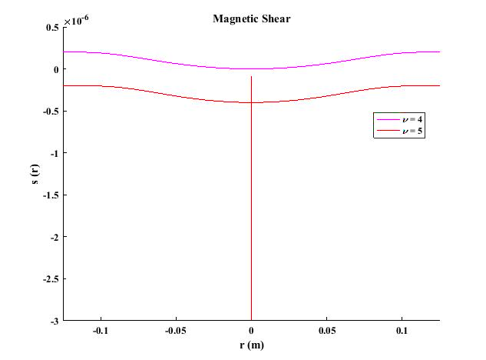

Figure 3. Magnetic shear profile for values $ν=4,5$ in IR-T1 tokamak.

By specifying the magnetic shear profile as well as the $s_{1}$ values, $γτ_{A}$ can be obtained for this tokamak for $ν=4 and 5$, which is shown in Fig. 4. The $γτ_{A}$ values obtained in Fig. 4 are equal to 0.09574 for $ν=4$ and 0.1266 for $ν=5$. The amount of Alfvenic time for this tokamak is:

$$τ_{A}=\sqrt{3}\frac{R_{0}}{v_{A}}=\sqrt{3}\frac{R_{0}\sqrt{μ_{0}ρ_{e}m_{i}}}{B}=0.158 μs$$

Therefore, the $γ$ values ​​for $ν=4 and 5$ are $0.6×{10}^{6} s^{-1}$ and $0.8×{10}^{6} s^{-1}$, respectively. The comparison of this approximate value with the maximum growth rate in Fig. 2 is a relative confirmation, at least in terms of the order of the values, on our calculations.

**4 Conclusions**

The ideal MHD instabilities due to the current or pressure gradient represent the final boundary of the operating limits for most magnetic fusion configurations. These possible instabilities fall into the category of ideal and resistance states. The ideal internal kink instability has been considered as an effective factor in disruptions and therefore in this work the stability of this mode­ in IR-T1 tokamak has been investigated. In this study, we found that instability associated with internal kink only grew locally for higher $ν$ values ​​(4,5) and in the central regions of the plasma. Therefore, this instability can be prevented by adjusting the toroidal current density profile. Also, for all quantities, we saw the most stability for this mode near the plasma boundary. A typical comparison with the results of fitting the data with the KINX simulation code also shows a good agreement in terms of the order of the obtained values. Finally, the study of time variation of safety factor and consequently the growth rate of internal kink instability, detailed study of poloidal magnetic flux functions and considering nonlinear effects as well as resistance effects on the growth rate of internal kink instability can have different and remarkable results for the performance of tokamak during its discharge compared to the linear results obtained in this study, which will be the subject of future works.

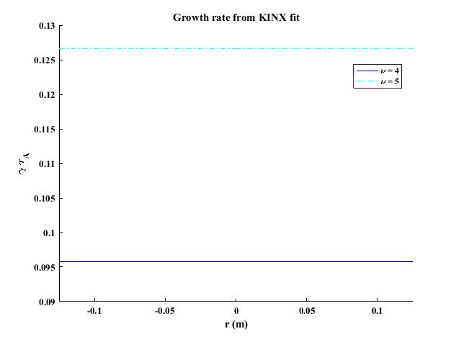

Figure 4. The growth rate of internal kink instability from fitting of KINX code results in IR-T1 tokamak for values $ν=4,5$.

**References**

[1]­ S. ­Ortolani and D.D. Schnack, 1993. Magnetohydrodynamics of Plasma Relaxation*,* World Scientific Publishing, Singapore Pte Ltd, pp. 15-43.

[2] R.J. Hosking, “Computation of Visco-resistive MHD Instabilities”, Journal of Comput. Physics.66, 274 (1986).

[3] A. Gsponer, 2009. “Physics of high-intensity high-energy particle beam propagation in open air and outer-space plasmas”*,* [arXiv: Plasma Physics. /0409157v 3](https://arxiv.org/abs/physics/0409157v3).

[4] H. Zohm, 2015. Magnetohydrodynamic Stability of tokamaks,1st ed.*,* Wiley-VCH, Garching.

[5] Ph.­D thesis, V.S. Lukin, 2008. “Computational study of the internal kink mode evolution and associated magnetic reconnection phenomena“. Princeton University, MA. Retrieved from https://ui.adsabs.harvard.edu/abs/2008PhDT.........1.

[6] Ph.D thesis, L H. de Blank, 1990. “Theory of the m=1 kink mode in toroidal plasmas“. The National University in Utrecht. Retrieved from https://inis.iaea.org/collection/NCLCollectionStore/_Public/22/006/22006377.pdf

[7] J. Mendonca, et al., 2019. “Simulation of the internal kink mode in visco-resistive regimes“, arXiv: Physics.plasma-ph, 1911.04028v1.

[8] C. Angioni, et al., “Effects of localized electron heating and current drive on the sawtooth period”, Nucl. Fusion. 43, 455 (2003).

[9] Ph.D thesis, L. Guazzatto, 2005. “Equilibrium and stability of tokamak plasmas with arbitrary flow“. University of Rochester, Rochester, New York. Retrieved https://www.lle.rochester.edu/media/publications/documents/theses/Guazzotto.pdf

[10] T. Kass, et al., “The fishbone instability in ASDEX Upgrade”, Nucl. Fusion, 38, 807 (1998).

[11] S. Günter, et al., “Influence of fishbones on the  
background plasma”, Nucl. Fusion, 39, 1535 (1999).

[12] F. Dini and S. Khorasani, “Study of magnetohydrodynamic stability in Damavand tokamak with large aspect ratio”, J. of Nuclear Sci. and Tech, 49, 14 (2009) (In Persian).

[13] M. Ghoranneviss, et al., “Measurements of the plasma current density and Q-profiles in IR-T1 tokamak”, Journal of Fusion Energy.­ 29(3), 232 (2010).

[14] S. Cowley, 2007. Introduction to kink modes-the Kruskal-Shafranov limit, UCLA, Lecture# 3; J.P. Friedberg, 1987.Ideal magnetohydrodynamics, 1st ed., Plenum, New York.

[15] M. Ghoranneviss and S. Meshkani,2017. Plasma Science and Technology for Emerging Economies, edited by R.S. Rawat, Springer Nature, Singapore Pte Ltd, pp. 413-474.

[16] L. Degtyarev, et al. “The KINX ideal MHD stability code for axisymmetric plasmas with separatrix”,Comput. Phys. Commun.103(1),­ 10 (1997).

[17] A. Martynov, J.P. Graves and O. Sauter, “The stability of the ideal internal kink mode in realistic tokamak geometry”, Plasma Phys. Control. Fusion 47, 1743 (2005)*.*