**Holographic dark energy from f(G) modified gravity perspective**

S. Noori Gashti1, J. Sadeghi2 , A. S. Sefiedgar3

1Department of Physics, Faculty of Basic Sciences, University of Mazandaran

P. O. Box 47416-95447, Babolsar, Iran

Email: saeed.noorigashti@stu.umz.ac.ir

2 Department of Physics, Faculty of Basic Sciences, University of Mazandaran

P. O. Box 47416-95447, Babolsar, Iran

Email: [pouriya@ipm.ir](mailto:pouriya@ipm.ir)

3 Department of Physics, Faculty of Basic Sciences, University of Mazandaran

P. O. Box 47416-95447, Babolsar, Iran

Email: a.sefiedgar@umz.ac.ir

**Abstract.** In this paper, we evaluate the cosmological implications of dark energy from a holographic perspective in the framework of a modified Gauss-Bonnet theory of gravity f(G) with respect to the Granda-Oliveros cut-off. Therefore, using holographic dark energy (HDE) and two forms of the scale factor, we reconstruct the f(G) model and study the different conditions such as energy conditions (WEC), (DEC), and (SEC) and show whether it is satisfactory or not. Also, we discuss the dynamic analysis of these models regarding the important tools as statefinder diagnostic (r, s). Finally, we study the stability of the two models and compare the results with the latest observable data.

Keywords: Holographic dark energy, Modified f(G) theory, Energy conditions,

**1 Introduction**

Recently various phenomena studied by researchers have been proven thanks to recent observations, such as the phenomenon of the accelerated universe, inflation, black holes [1, 2, 3, 4]. Since the nature of dark energy is still unknown, different models are considered for it and compared with the latest observable data. The simplest model that is a candidate for dark energy is ΛCDM. Also, other dynamic models are mentioned [3, 4]. Of course, determined to differentiate each dark energy model using the equation of state parameter ω = p eff /ρ eff. So far, various candidates for dark energy introduced in the literature, and recent efforts have led to the introduction of many newer models that are compatible with the latest observable data and cosmic phenomena [3]. As mentioned, recent observations have been made through SNe Ia, indicating that a number of these dynamic models are more compatible with recent cosmic phenomena than the constant cosmological model Λ-Dark energy, despite its unknown nature, has always been deeply analyzed [5]. One of the most important dynamic models of dark energy is called (HDE), which researchers have recently considered and evaluated from a different perspective. Its cosmological implications have also been studied [6]. Dynamic models of dark energy studied in various types of structures, including the modified theories of gravity, which play a very important role for the late acceleration of the universe [4]. Researchers deeply considered modified theories also include different types such as f (R) gravity, f (R, t) gravity, f (T) gravity, braneworld models, Gauss-Bonnet gravity, and Galileon gravity, in various types of cosmic studies. The ones used the modified scalar-Gauss-Bonnet theory of gravity in many cosmology studies and investigated its cosmological implications. Scalar-Gauss-Bonnet gravity in form f (G) in [7] has been introduced. This theory also somehow describes the acceleration of the universe and the different periods of radiation/matter-dominated eras, which by Myrzalulov [8] checked out. In [10], They considered different and specific forms of theory f (G) and examined inequalities concerning different energy conditions, and showed the viability of different forms of f (G) theory. Now we will study different implications in the structure of the modified f(G) gravitational and the structure of HDE theory with respect to the Granda-Oliveros cut-off.

**2 HDE & f(G) gravity**

This section will first review the modified theory of gravity f(G) and then discuss the HDE structure and the reconstruction of our theory. The action of a modified theory of f(G) gravity in which Einstein’s gravity coupled with a perfect fluid concerning the structure of Gauss-Bonnet term is described as ∫d4x [11]. According to this equation, G = R2 − 4RµνRµν + Rµνλσ Rµνλσ, k2 = 8πG, R, Rµν, Rµνλσ and g determine the Ricci scalar curvature, Ricci curvature tensor, Riemann curvature tensor and metric tensor gµν, respectively. Also, in the above equation, the parameter Lm represents the Lagrangian of the matter present. The variation of this equation with respect to a parameter gµν called the metric tensor leads to the field equations as follows.

1/2k 2 (−Rµν + 1 2 gµν R) + Tµν + 1 2 gµν f(G) − 2fGRRµν + 4fGRµρRνρ − 2fGRµρστRνρστ − 4fGRµρσνRρσ + 2(∇µ∇ν fG) R − 2gµν(∇2 fG)R − 4(∇ρ∇µ fG)Rνρ − 4(∇ρ∇ν fG)Rµρ + 4(∇2 fG)Rµν + 4gµν(∇ρ∇σ fG)Rρσ − 4(∇ρ∇σfG)Rµνρσ = 0 (1)

In the above equation, fG = df/dG and the two functions f and Tµν specify the energy-momentum tensor of the perfect fluid, respectively. But in this paper, we have a special form of gravitational f (G) mentioned in [11]. We suffice and continue the equations with this form of f(G). In general, the two parameters R = 6(dH /dt +2H2 ) and G = 24H2 (dH/dt +H2 ), which determine the Ricci scalar curvature and Gauss-Bonnet invariant in spatially flat FRW space-time. The spatially homogeneous space FRW mentioned above is specified as ds2 = −dt2 + a2 (t)(dx2 + dy2 + dz2 ). Where a(t) is the scale factor. In these above equations, the dot is a time derivative. According to the above explanation, the first equation of FRW concerning 8πG = 1 is in the following form.

H2 = 1/3 (G fG − f(G) – 24dG/dt H3 fGG + ρm) = 1/3 (ρG + ρm) (2)

Where fGG = d2 f /dG2. The subscripts (m) in the equations represent matter’s contribution in each of the quantities of energy density and pressure. We now present a reconstructed scheme for studying gravity f (G) in a holographic dark energy structure with a Granda-Oliveros cut-off. The holographic energy, as well as the Granda-Oliveros cut-off (LGO,) are shown as follows [19].

ρΛ = 3 /L2GO , LGO = (δ dH/dt +λH2)-1/2  (3)

λ and δ are constant parameters in the above equation. Dimensionless DE density can obtain according to energy density ρΛ of dark energy and critical energy density ρcr = 3H2; ΩΛ = ρΛ / ρcr = c2 /L2GO H2. The equation of state parameter is as ωeff = peff / ρeff. So,

ρeff = ρ + 1/2k2 (− f(G) + 24H2 (H2 +dH/dt )fG ) (4)

peff =p + 1/2k2 (f(G) − 24H2 (H2 + dH/dt )fG + 8(24)H2 (6[dH/dt]3 + 6HdH/dt d2H/dt2 + 24H2 (dH/dt)2 + 6H3 d2H/dt2 + 8H4 dH/dt + H2 d3H/dt3 ) fGG + 8(24)2H4 ( 2H2 + H d2H/dt2 + 4H2 dH/dt )2 fGGG) (5)

Setare in [13] examines such a reconstruction about the modified gravitational f(R) model in the framework of HDE, and we somehow study such a structure in the case of the modified gravitational f(G) model concerning two different models of the scale factor. Now concerning the energy density of f (G) gravity in equation (2) and energy density of HDE model in equation (3) will lead to the following differential equation [9]

24H3 (dG/dt)−1 d2f(G)/dt2 − (24H3 (dG/dt )−2 d2G/dt2) df(G)/dt + f(G)

= −3(δ dH/dt + λH2 ) (6)

**3 Model I**

As shown in the reconstruction of f(G) gravity in equation (10), investigating is very difficult to solve this equation analytically. Therefore, we prefer the numerical solution for this gravitational model, so that we introduce two scale factors and then examine the modified f(G) gravity structure in the HDE framework. Hence the first ansatz of the scale factor model, a hybrid model, is expressed in the following form.

a(t) = (tσ − t)n exp(t) (7)

Where tσ and n are constant parameters. According to the above ansatz, we consider the hybrid form tn exp(t). By selecting this scale factor and explaining it in the previous section, we can easily calculate quantitative values as H and G, as follows. H = (n + t)/ t and G = (24(n + t)2 ((-1+n) n+2nt+t2))/t4 . Observing a constraint on the form limG→0 f(G) = 0 indicates that the above reconstructed model has sufficient conditions to validate that the HDE f(G) model is a realistic model. Hence, the reconstruction of the f(G) model given in the above equations shows the compatibility of the modified theories of gravity with HDE.

**4 Model II**

We introduce another ansatz of scale factor and follow the same process as before.

Hence, the new model is expressed in the following form.

a(t) = β t exp(αnt) (8)

Where n, α and β are constant parameters. Now we can easily calculate quantitative values as H and G as follows, H = αn + 1/ t and G = (24αn (1 + αnt)2 (2 + αnt))/ t3. Also, to calculate functions and plot them, we used numerical methods to solve problems that may cause difficulties in calculating and plotting analytical figures.

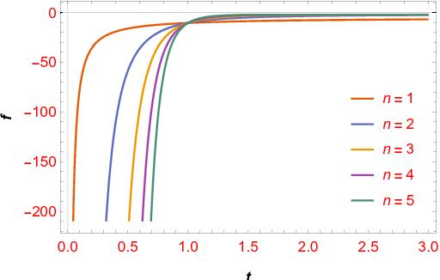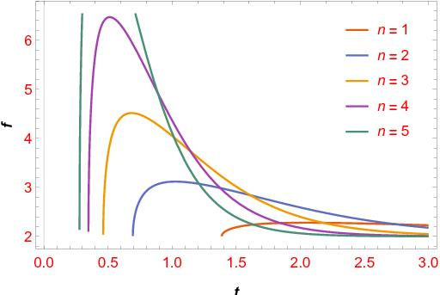

Figure 1. The plan of f(G) in terms of t in fig (1a) for model I and in fig (1b) for model II, according to the different values of n and constant parameters α = β = 0.1, λ = 1.5 and δ =1

We plotted the changes of the modified f(G) gravitational model in the HDE structure for the model I in figure (1a) and model II in figure (1b) in terms of variables t according to the constant parameters α = β = 0.1, λ = 1.5 and δ = 1 respectively. As mentioned in the text, the increased values of f(G) are related to the increase of the parameter t, and finally it converges zero value. For the second model, changes occur in proportion to time passage. For different constant parameters as shown in the figure on the right, first an increase occurs, and then the figure takes a decreasing direction. These conditions can ensure for HDE f(G) theory as a realistic model.

**5 Energy condition of I and II**

Different types of these energy conditions such as (NEC), (WEC), (DEC), and (SEC) can be named, which obtained in a special form through the Raychaudhuri equation [10] also in different scenarios, such as the evolution of the deceleration parameter, phantom field potential, and an expansion scenario of the universe [12]. About different energy conditions, NEC and the WEC are very important despite their simplicity. Dissatisfaction or violation of the NEC energy condition will lead to the violation of other energy conditions, so it is important. This issue guarantees the second law of thermodynamics and indicates a decrease in energy density during the accelerating expansion of the universe. Violation (SEC) also indicates the rapid expansion of the universe. In general, can describe the different energy conditions for the mentioned theory in the following form. [10], NEC = ρef f + pef f ≥ 0, W EC = ρef f ≥ 0, ρef f + pef f ≥ 0, DEC = ρef f ≥ 0, ρef f ± pef f ≥ 0, SEC = ρef f + 3pef f ≥ 0, ρef f ± pef f ≥ 0. We can determine the energy conditions for the first model using equations (4), (5) and (7) and for the second model with the equations (4), (5) and (8). After calculating these energy conditions, it is possible to determine the satisfaction or violation of energy conditions by plotting some figures. We show the energy conditions for model (I) in figure (2a) and model (II) in figure (2b, 2c, 2d) for mentioned constant values and parameters. In Figure (2), the NEC energy conditions for the two models violated except will be satisfactory for model II for the even values of n. Also, the condition of violation or satisfaction of these cases is clear. But, in all cases, except for the even n in model II, the SEC is violated. Its violation is a confirmation of the accelerated expansion of the universe.

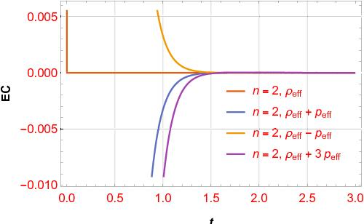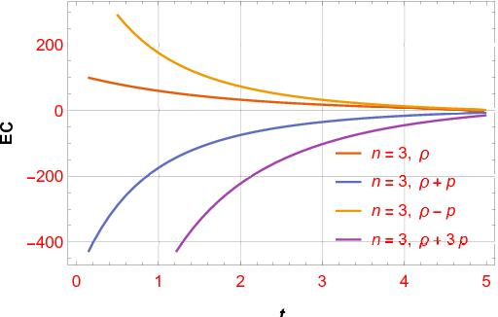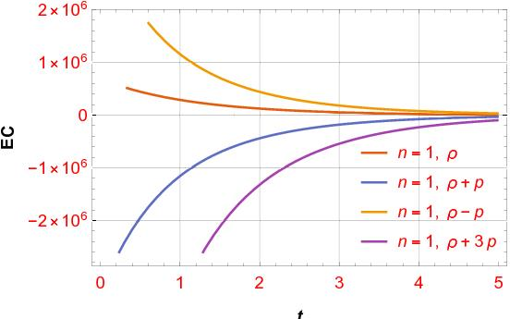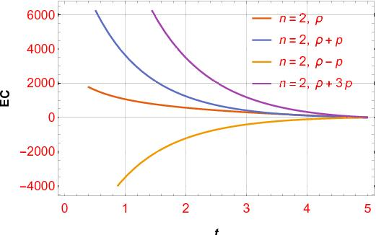

Figure 2. The plot of EC in terms of t in fig (2a) for model I and in fig (2b, 2c, 2d) for model II, according to the different values of n and constant parameters α = β = 0.1, λ = 1.5, δ = 1

**6 Stability of I and II**

Now we want to check the stability of our mentioned model with the help of sound speed. Hence we will have. C2s = (dpΛ/dt) / (dρΛ/dt). As it is clear from the above equation, the sign of the above equation is very important because the negative or positive of the above equation indicates the stability or instability of the models. The negative value of the above equation indicates the classical instability of a certain perturbation in general relativity [14, 15]. A very important point about the speed of sound in the HDE structure is that there must always be a negative value in the future event horizon as IR cutoff [15]. However, for two forms, Chaplygin gas and tachyon, a non-negative value is observed. Researchers also investigate the sound speed in agegraphic DE structures. It has a negative value, which leads to perfect fluid instability for the model. [14] Also, one studied Various structures such as the ghost QCD DE model in this field, which shows the system’s instability. Here we plot the speed of sound in terms of cosmic time for two models. The figures show that sound speed values for both present and future times are negative, depicting classical instability for both models. In other words, the modified f (G) gravitational model in the HDE structure is classically unstable for both scale factor models.

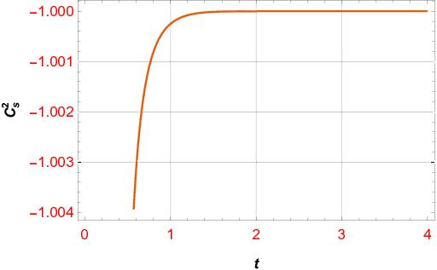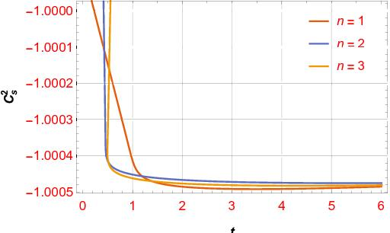

Figure 3. The plot of C2s in terms of t and n = 2 in fig (3a) for model I and in fig (3b) for model II, according to the different values of n and constant parameters α = β = 0.1

**7 Statefinder diagnostic**

It has often been difficult to distinguish between different models for dark energy. So for solving this problem, the ones used a diagnostic pair (r, s) statefinder in [16, 17] as r = (da/dt)3/aH3 and s = (r – 1)/ 3(q − ½). These equations show that the decelerating parameter q = − (d2a/dt2) / (aH2) and the Hubble parameter is as H = (da/dt) /a. This powerful tool deals with the first to third derivatives of the scale factor and shows the geometric properties of dark energy. We can name earlier interesting work, including studying modified HDE in the Kaluza-Klein universe, two dark energy models with powerful diagnostic tools (Panotopoulos), and different forms of dark energy in the Kaluza-Klein universe. [18]. This diagnostic tool distinguishes between a wide range of dark energy in different states such as the cosmological constant, Chaplygin gas, quintessence, braneworld models, the interacting DE, etc. [16]. We know that the constant point of the pair r = 1, s = 0 indicates the standard model of dark energy, i.e. (Λ-Cold-dark-mater), which the mentioned models can reach and passing it. It means that these models can reach this phase of the universe. Figure (4) also shows the changes of two very important parameters of the powerful diagnostic tool (r – s) for both models. As it is clear, the changes of {r − s} trajectories are shown for the model I in figure (4a) and model II in figure (4b) for various values of constant parameters as n. As it is clear in both models, {r − s} trajectories reach the constant points related to the Λ-CDM model with the specification (r = 1, s = 0) and pass it well. It is a kind of indication that this structure is reconstructed for different values considered for constant parameters. According to both models mentioned in the text, it can reach the Λ-CDM phase of the universe

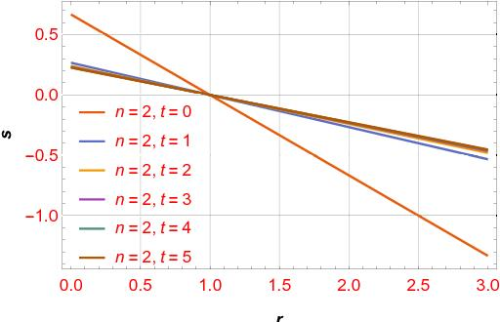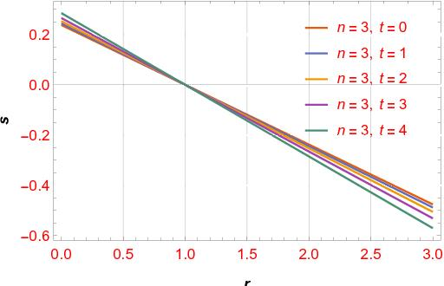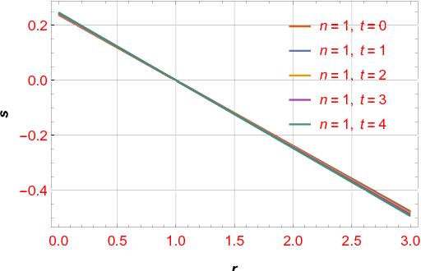

Figure 4. The plot of s in terms of r in fig (4a) for model I and in fig (4b,4c) for model II, according to the constant parameters α = β = 0.1, λ = 1.5 and δ = 1

**8 Conclusions**

In this paper, we evaluated some cosmological implications of dark energy from a holographic perspective concerning various form factor scales, i.e., tn exp(t), βt exp(αnt) and in the framework of a modified Gauss-Bonnet theory of gravity; f(G) with respect to the Granda-Oliveros cut-off. Therefore, using holographic dark energy (HDE) and two different forms of the scale factor, we reconstructed the f(G) model and studied the different conditions of these models. Also, by defining effective energy density ρeff and pressure peff , we investigated different energy conditions EC such as (WEC), (DEC), and (SEC) and show whether it is satisfactory or not. Also, we examined the behavior of the equation of state (EoS) using the two parameters ρeff and peff and the other constant parameters. Then we discussed the dynamic analysis of these models regarding the important tools as statefinder diagnostic (r, s). Finally, we studied the stability of the two models and compared the results with the latest observable data. Of course, an important issue that can focus on in future work is to study the different conditions of the swampland program, such as the refined swampland conjecture and TCC.

**References**

[1] D. N. Spergel et al., Astrophys. “First-Year Wilkinson Microwave Anisotropy Probe (WMAP)* Observations: Determination of Cosmological Parameters” J. Suppl. 148 175 (2003).

[2] S. Perlmutter et al., “Measurements of Ω and Λ from 42 High-Redshift Supernovae Astrophys. J. 517 565 (1999).

[3] E. J. Copeland, M. Sami and S. Tsujikawa, “Dynamics of dark energy” Int. J. Mod. Phys. D 15 1753 (2006).

### [4] S. Tsujikawa, “Modified gravity models of dark energy” Lect. Notes Phys. 800 99 (2010).

### [5] M. Li et al., “[Dark energy](https://arxiv.org/pdf/1103.5870)” Commun. Theoret. Phys. 56 525 (2011).

### [6] Shuang Wang, Yi Saeed Pourojaghi, and Mohammad Malekjani,”  [A new comparison between holographic dark energy and standard  Λ -cosmology in the context of cosmography method](https://link.springer.com/article/10.1140/epjc/s10052-021-09393-1)’’ The Euro. Phys. J C81 575 (2021).

### [7] S. Nojiri and S. D. Odintsov, “[Modified Gauss–Bonnet theory as gravitational alternative for dark energy](https://www.sciencedirect.com/science/article/pii/S0370269305014619) ” Phys. Lett. B 631 1 (2005).

### [8] R. Myrzakulov, D. Sez-Gmez and A. Tureanu, “[On the Λ CDM Universe in f (G) gravity](https://link.springer.com/article/10.1007/s10714-011-1149-y) ” Gen. Relativ. Gravit. 43 1671 (2011).

### [9] S. Nojiri, and S. D. Odintsov, “[Introduction to modified gravity and gravitational alternative for dark energy](https://www.worldscientific.com/doi/abs/10.1142/S0219887807001928)” Int. J. Geom. Meth. Mod. Phys. 4 115 (2007).

### [10] N. M. Garcia, T. Harko, F. S. N. Lobo and J. P. Mimoso, “Energy conditions in modified Gauss-Bonnet gravity ” Phys. Rev. D 83 104032 (2011).

### [11] S. Nojiri and S. D. Odintsov, “Modified Gauss–Bonnet theory as gravitational alternative for dark energy ” Phys. Lett. B 631 1 (2005).

### [12] A. A. Sen and R. J. Scherrer, “The weak energy condition and the expansion history of the Universe ” Phys. Lett. B 659 457 (2008)

### [13] M. R. Setare, “Holographic modified gravity ” Int. J. Mod. Phys. D 12 2219 (2008).

### [14] K. Y. Kim, H. W. Lee and Y. S. Myung, “Instability of agegraphic dark energy models ” Phys. Lett. B 660 118 (2008). [14] K. Y. Kim, H. W. Lee and Y. S. Myung, “Instability of agegraphic dark energy models ” Phys. Lett. B 660 118 (2008).

### [15] Y. S. Myung, “[Instability of holographic dark energy models](https://www.sciencedirect.com/science/article/pii/S0370269307008787) ” Phys. Lett. B, 652 223 (2007).

### [16] Vandna Srivastavaab UmeshKumar Sharma, “[Statefinder hierarchy for Tsallis holographic dark energy](https://www.sciencedirect.com/science/article/pii/S1384107619303008) ” New Astronomy 78, 101380 (2020).

### [17] V. Sahni, A. Shafieloo, and A. A. Starobinsky, “[Two new diagnostics of dark energy](https://journals.aps.org/prd/abstract/10.1103/PhysRevD.78.103502) ” Phys. Rev. D 78 103502 (2008).

### [18] M. Sharif, and A. Jawad, “[Modified holographic dark energy in non-flat Kaluza–Klein universe with varying G](https://link.springer.com/article/10.1140/epjc/s10052-012-1901-9) ” Europ. Phys. J. C 72 1901 (2012).

### [19] M.R. Setare, “[Holographic modified gravity](https://www.worldscientific.com/doi/abs/10.1142/S0218271808013819) ” Int. J. Mod. Phys. D 12 2219 (2008).